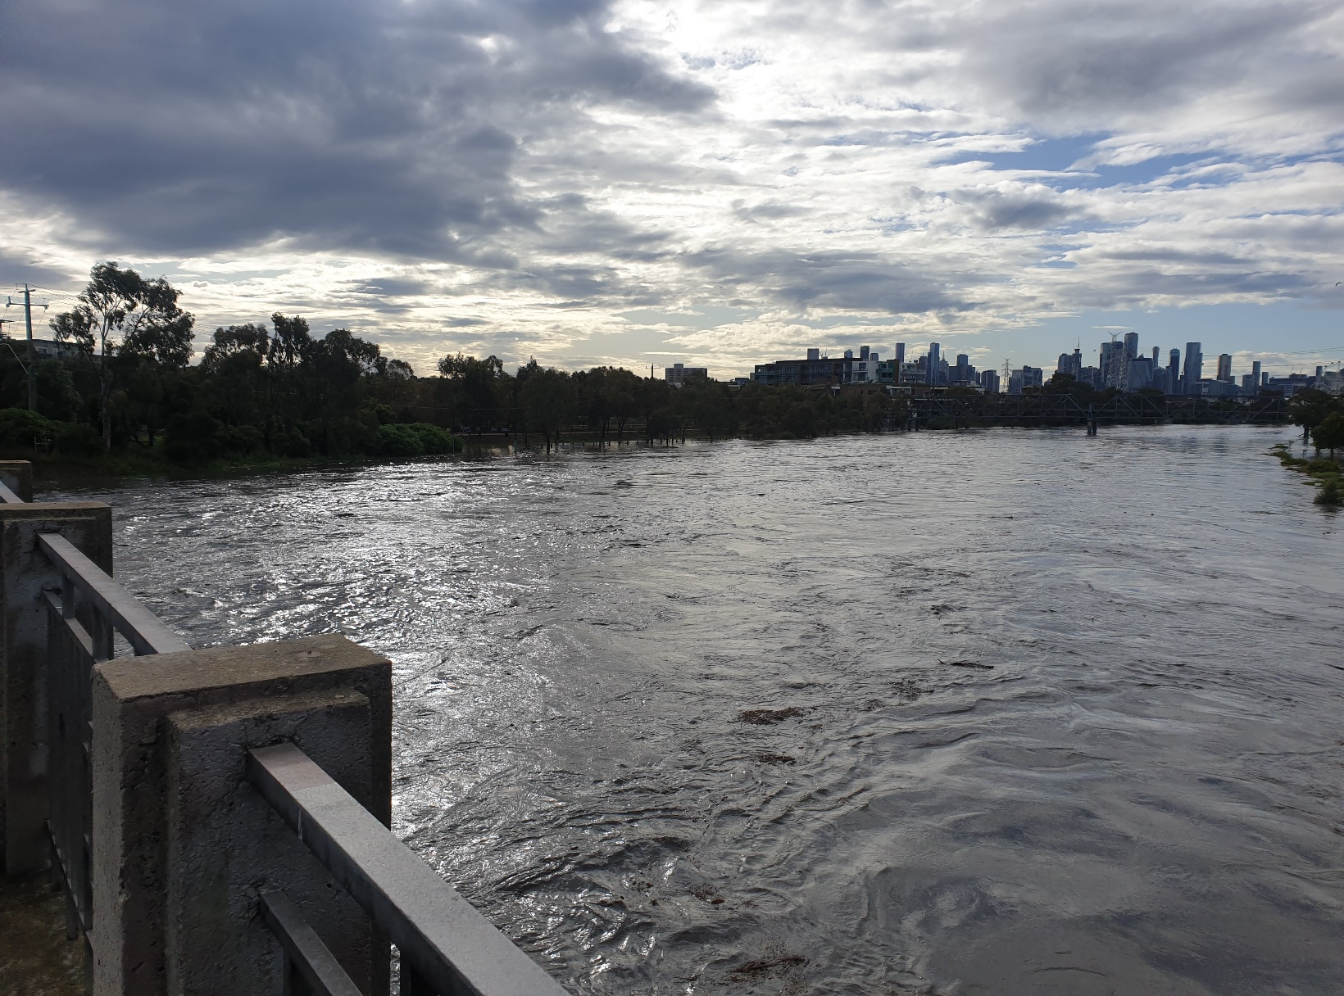
Community Partnership Panel (CPP) Terms of Reference
Maribyrnong River Catchment Flood Mitigation Study

April 2025

Table of contents
Introduction 3
Purpose 4
Selection Process 5
Selection Criteria 6
Membership 8
Roles and responsibilities of Community Partnership Panel Members 9
Roles and Responsibilities of Jacobs 10
Scope and Influence 13
Reporting 14
Decision-making process 15
Meetings 16
Governance 17
Updates to Terms of Reference 18
Termination of Terms of Reference 19

Introduction
The Maribyrnong River is highly flood prone, with instances of flooding recorded as early as the 1800s. In October 2022, the lower Maribyrnong River Catchment experienced a significant flood event which impacted four Local Government Areas across Melbourne. Over 500 properties, including residences, businesses, and other public and private assets, were impacted, causing both physical and financial damage, and negatively impacting the physical health, mental health, and wellbeing of many who experienced the event.
Following the 2022 event, an Independent Review Panel commenced the Maribyrnong River Flood Review and released their findings in late 2023. In keeping with one of the recommendations produced by the review, Melbourne Water investigated the flooding mechanisms of the 2022 flood event and developed a Maribyrnong River Flood Model which incorporated new information from the 2022 flood. With the completion of the Maribyrnong River Flood Modelling, Melbourne Water is seeking to collaborate with customers, community members and stakeholders to develop a range of flood mitigation options, through the Maribyrnong River catchment mitigation study (the study). The study will investigate flood mitigation options to reduce flood risks in the Maribyrnong River catchment area.
Melbourne Water has committed to developing these flood mitigation options in collaboration with customers, community, and stakeholders. The Community Partnerships Panels will be one part of the comprehensive engagement program to develop the flood mitigation options together with customers, community and stakeholders.

Purpose
The Community Partnership Panels aim to involve community and stakeholders in the decision-making process to identify and evaluate mitigation options. Community and stakeholder participation in the Community Partnership Panels provides a way to foster effective partnerships that can lead to study outcomes which better reflect the needs and priorities of the community.
The Community Partnership Panels will support open and transparent communication between Melbourne Water, community and stakeholders. The Community Partnership Panels will provide a platform for community members to learn more about the possible flood mitigation options and provide their feedback and perspectives to help shape these.

Selection Process
The mitigation options that may be suggested, identified, and considered will potentially be located or implemented across the entire Maribyrnong River Catchment. It is therefore important that the membership of the three Community Partnership Panels reflect the diverse perspectives, backgrounds, geographic locations, and areas of knowledge of a range of community members across the Maribyrnong River Catchment.
Prospective Community Partnership Panel members will be asked to submit an Expression of Interest form via the Melbourne Water Let’s Talk website.
The Expression of Interest will ask the following questions:
- Do you agree to the Terms of Reference for the Community Partnership Panel?
- Do you live or operate a business in the catchment area?
- What is your age group?
- Which best describes your gender?
- Do you identify as Aboriginal or Torres Strait Islander?
- What language do you speak at home?
- Do you require any assistance when participating in the Community Partnership Panels due to language support needs (i.e. an interpreter, translated materials, cultural modifications)?
- Are you a person living with disability and require assistance when participating in the Community Partnership Panels?
- How would you like to be contacted by the project?
- Is there any information you would like to share about why you are interested in joining a Community Partnership Panel?
- Do you intend to represent a community group? If so, which one?

Not all the questions in the Expression of Interest relate to the selection criteria, instead this information is being collected to help us better support members of the catchment to participate in the Community Partnership Panel, especially around accessibility requirements.

Selection Criteria
To be eligible for the Community Partnership Panels, potential members need to:
- Reside or run a business in the Maribyrnong River Catchment, including one of the following suburbs: Aberfeldie, Airport West, Ascot Vale, Ashbourne, Avondale Heights, Benloch, Beveridge, Bolinda, Braybrook, Bulla, Bullengarook, Bylands, Calder Park, Cherokee, Chintin, Clarkefield, Cobaw, Darraweit Guim, Delahey, Diggers Rest, Essendon, Essendon Fields, Essendon North, Essendon West, Flemington, Footscray, Forbes, Fraser Rise, Gisborne, Gisborne South, Gladstone Park, Goldie, Hesket, Hillside, Kealba, Keilor, Keilor Downs, Keilor East, Keilor Lodge, Keilor North, Keilor Park, Kensington, Kerrie, Kilmore, Lancefield, Lerderderg, Macedon, Maidstone, Maribyrnong, Mickleham, Monegeetta, Moonee Ponds, Mount Macedon, New Gisborne, Newham, Niddrie, Nulla Vale, Oaklands Junction, Pastoria, Pipers Creek, Riddells Creek, Rochford, Romsey, Seddon, Springfield, St Albans, Strathmore Heights, Sunbury, Sunshine, Sunshine North, Sydenham, Taylors Hill, Taylors Lakes, Tullamarine, Wallan, West Footscray, West Melbourne, Westmeadows, Wildwood, Willowmavin, Wooden, Yarraville and Yuroke.
- Be at least 16 years and older at the time the expression of interest is submitted.
- Agree to reflect the broad interest and knowledge of the Maribyrnong River Catchment community during Panel conversations.
To ensure independence, members of the Community Partnership Panels cannot be a:
- Former or current employees of Melbourne Water or Jacobs
- Former or current employees of Local Government
- Former or current elected member of Local, State or Federal Government.
Recognising the active and engaged community organisations relating to the Maribyrnong River and flood recovery, a minimum of five members across the Community Partnership Panels will be reserved for representatives of community groups and organisations. These community groups and organisations will ensure the Community Partnership Panels reflect a broader section of the impacted community.
Those people who submit an Expression of Interest will be added to a draw. A digital randomisation tool will be used to select potential members. The tool uses demographic data from the 2021 census to create a representative demographic profile of the panel membership, based on a range of demographic categories. The randomisation tool helps identify members, which broadly match with the representative demographic sample created.
The sample will be based on four demographic categories:
- Suburb: based on suburbs within the catchment as included in the Terms of Reference.
- Gender: male, female and non-binary.
- Age: based on age range from 16 and over.
- Language used at home (based on the top languages spoken across the catchment, in descending order): Vietnamese, Mandarin, Italian, Cantonese, Greek, Arabic, Macedonian, Spanish, Croatian, Punjabi, Turkish, Other.
This process will be run by Jacobs independently from Melbourne Water and is based on a tried and tested recruitment approach. Jacobs is supporting Melbourne Water more broadly with the delivery of the flood mitigation study.
Recruitment and Advertising
The Expression of Interest will be advertised across multiple digital and physical communication channels, including, letter box drops, social media, the Melbourne Water Let’s Talk Website, and emails to people who have subscribed to updates on the study. It will be open for 30 days.
A digital agreement will be included with the Expression of Interest which states prospective members have read and agree with this Terms of Reference Document.

Membership
There will be three Community Partnership Panels, which will each comprise of approximately 20 members from across the Maribyrnong River catchment. Across the three Panels there will be approximately 60 members.
If we are unable to attract the required number of members to fill three panels, we may choose to reduce the number of Community Partnership Panels.
If we fail to attract the required number to fill two panels (minimum of 15 people per panel, or minimum 30 people overall) then we will not proceed with the Community Partnership Panels. We recognise the Community Partnership Panels need to be reflective of the communities within the catchment, and panels which are smaller in size may not capture the diversity or feedback of a larger group panel.

Roles and responsibilities of Community Partnership Panel Members
The Community Partnership Panels require a minimum commitment of nine hours from each member over the course of the study. However, there will be times where Community Partnership Panels members are asked to read materials ahead of a session and share information with their networks after a session.
Melbourne Water acknowledges that the Community Partnership Panels are a considerable commitment for community members, especially those who may have been impacted by a flooding event or have already actively participated in past engagement since the flood in 2022.
We ask that you consider whether you can commit to the roles and responsibilities of Community Partnership Panels members, the time commitment required and make a decision that feels right for you. There will be several other ways to share your feedback and engage with the study if the Community Partnership Panels feels like too much of a commitment.
Compensation
- Members will be compensated $200 for each session they attend in the form of a physical Eftpos Gift Card. The Gift Card will be provided at the end of each session. Members will only be paid for the sessions they attend.
Term
Members will serve a term of around 15 months on a Community Partnership Panel, from early-2025 to mid-2026. Each Community Partnership Panel meeting will be scheduled to run for three hours, meaning members will undertake a total time commitment of nine hours, at a minimum, across this 15-month period.

Roles and Responsibilities of Jacobs
Jacobs will:
- Arrange and facilitate all meetings
- Ensure all meetings of the Community Partnership Panels are accessible, including the provision of interpreters and translators
- Provide an agenda and where relevant, materials will be provided to allow attendees to prepare for the meeting at least one week in advance of meetings
- Record and distribute summary of issues discussed to attendees following each session. These will not detail individual comments made by panel members, but instead provide a summary of the issues raised.
- Be transparent about how feedback shared through the Community Partnership Panels has been considered and informed the study outcomes.

General Conduct
Panel members are expected to act with respect, honesty and integrity, and are requested to:
- Agree to abide to the Community Partnership Panel Terms of Reference
- Participate in three in-person meetings, and to provide a notification/apology in advance where attendance is not possible
- Review provided materials and attend meetings prepared to constructively participate, actively discuss key issues, and provide feedback
- Actively discuss key issues and strategic documents with their networks to bring a representative voice to discussions
- Offer insights and recommendations on proposed ideas and initiatives
- Encourage open and transparent communication between Melbourne Water and the community.
- Allow for a broad range of feedback and perspectives to be expressed, reflecting the diversity of opinions, feelings and experience of community
- Acknowledge the challenges faced by individual stakeholders may be different
- Always seek to obtain and represent the views of the broader community
- Act in a courteous and respectful manner
- Respect the rights of others to express their views, even if they are different from their own
- Uphold an atmosphere where all members feel comfortable participating
- Engage in respectful and constructive dialogue, focusing on community challenges rather than individual issues
- Allow individuals to be clear about when representing an organisation, and when representing themselves or their networks.
- To respect the privacy of other members and not share information about their opinions, beliefs or involvement in the Community Partnership Panel without their permission.
- To not record audio or video, or take photos, of Melbourne Water staff and contractors, or other members, without their permission.
- To not speak publicly, including with the media, on behalf of the panel or Melbourne Water without permission
- Notify Melbourne Water of any potential or perceived conflicts of interest that may arise in relation to the Study.
Members who act aggressively or not in line with the above will be removed as a member of the Community Partnership Panels to ensure the safety and comfortability of all.
We will ask each member to sign their agreement to above before participating in the Community Partnerships Panels, at the first session.
Name:
Date:
Signature:

Scope and Influence
The Community Partnership Panels will consider and work to understand:
- What members value within their community and surrounding area
- What members would like to protect from future floods and why
- Members objectives and priorities for flood mitigation options
- Members experiences during past flooding events, relating to health, safety and accessibility.
- The tolerable level for risk of flooding for different catchment features.
- The decision-making criteria used to evaluate the flood mitigation options, including feasibility and cost.
- The feedback and recommendations provided by members on proposed mitigations.

Reporting
A regular report will be prepared that summarises the outcomes of each of the Community Partnership Panels at the end of each Phase that will be shared with members but also published on the Let’s Talk website.
A final report summarising the Community Partnership Panels findings and recommendations will be submitted at the end of the engagement program. The reports will summarise feedback provided and how it has been incorporated throughout the study.
All feedback provided by members during the Panels will be anonymised in these summary reports or any other documentation to respect the privacy of participating members.
We will not disclosure any personal information of any members of the Community Partnership Panels. We will seek all relevant and required permission, this may be to take photos or to release summary information about the panels and what was achieved.

Decision-making process
Decisions of the Community Partnership Panels will be made through a consensus approach – that is general agreement on issues. Every panel member holds equal weight.
Feedback collected from members during Community Partnership Panels will be viewed as equal to feedback collected from a member of the public through other engagement methods, whether the activities are in person or online.
The Community Partnership Panels are one avenue for community members to participate in the Study and provide feedback. Community members who are unable to commit or join the Community Partnership Panels will be able to offer their insights, feedback or contribute through other avenues such as community drop-in sessions or online engagement activities, please see the Let’s Talk website for further information. Throughout the life of the Study, there will be multiple ways a community member can be involved.
Feedback received during the Community Partnership Panels, and other community engagement events will help to identify and assess the mitigation options, alongside other consideration such as feasibility, cost, as well as social, environment and economic factors.

Meetings
The study has been split into four Phases, three Phases to identify and assess long-term and sustainable flood mitigation options and a final Phase to present the Study outcomes:
- Phase 1 – Identify what’s important to you
- Phase 2 – Exploring options
- Phase 3 – Reviewing and further feedback
- Phase 4 – Presenting Study outcomes
The Community Partnership Panel will meet once in Phase 1-3. Due to the nature of the study, there may be additional Panel sessions as required.
Meeting dates, times and locations will be communicated in advance to all members. Meetings will be held at different locations, all within the Maribyrnong River catchment area.
To maintain equity of access for all CPP members across the catchment, Melbourne Water may provide additional support to those travelling long distances to attend meetings.
We will strive to accommodate feedback received from CPP members about the delivery of sessions, including times, dates and locations, where possible.

Governance
The following provides an overview of the governance arrangements and engagement with Community Partnership Panel members for the study.
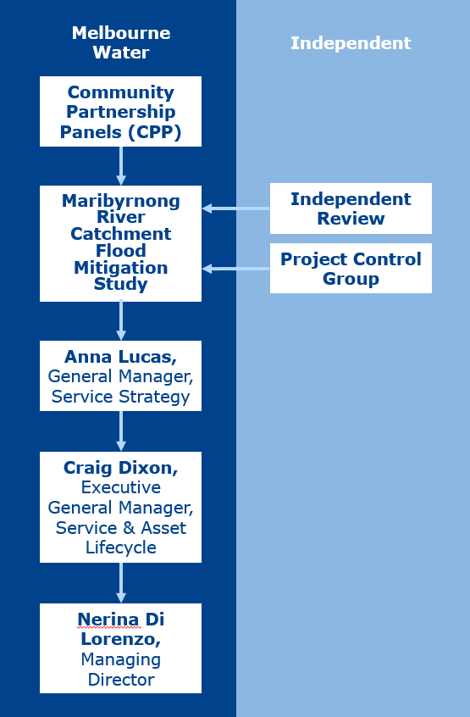

Updates to Terms of Reference
The study will be delivered over four Phases. The effectiveness of the panel will be reviewed after each Phase to ensure it meets its objectives and serves the community’s needs.
Feedback from members and stakeholders will be considered at the end of each Phase and the study team will make modifications to the Community Partnership Panels Terms of Reference, where reasonable and practicable.

Termination of Terms of Reference
This Terms of Reference concludes with the final Phase of the study engagement program. Melbourne Water will publish a Consultation and Feedback Report during Phase 4 of the study. This document will contain the summary of communications and engagement activities and will be used to measure success against objectives defined in the early phase of the study.

