AM STA Computer Aided Design (CAD) Standards
Standard
July 2025

Table of contents
Acronyms and Abbreviations 4
1. Purpose 5
2. Scope 5
3. Software Requirements 5
3.1 Platform 5
3.2 Version Requirement 5
3.3 3D Drawing Platform 5
4. References and Standards 6
5. Drawing Sheet Sizes and Orientation 7
6. Project Folder Structure 8
6.1 Non Autodesk Construction Cloud Workspace 8
6.1.1 WIP (Work In Progress) Directory 8
6.1.2 Shared Directory 9
6.1.3 Published Directory 9
6.1.4 Dated Directories 9
6.2 Autodesk Construction Cloud and Plant 3D Workspace 9
6.2.1 Plant 3D workspace using ACC 10
7. Project Naming Convention 11
7.1 Project Number in 11
8. Drawing Number Convention 11
8.1 Discipline Codes 11
8.2 CAD Filename Convention 11
8.3 Xref Filename Convention 11
9. Drawing Templates 12
10. Drawing Revision 12
10.1 Revision Cloud 12
10.2 Recording Revisions 12
11. Drawing Transmittal and Project Delivery 13
12. Drawing Stamps 13
13. Drawing Scales 13
14. Drawing Units 14
15. Datum and Coordinate Requirements 15
16. Line Type Scales 15
17. Colours and Pen Assignments 15
18. Layers/Level and Layer Naming Convention 16
19. Text Styles 16
19.1 Dimensions 17
19.2 Text Annotation 17
19.3 Text Masking 18
19.4 Example of Text Alignment 19
20. Standard Layers and Linetypes 19
21. Sections and Details 20
21.1 Sections 20
21.2 Details 21
21.3 Section and Detail Markers 21
22. Obsolete or Superseded Drawing 22
23. Use of External Drawings and Survey Data 22
24. GIS Data Importing and Exporting 23
25. Drawing Re-Numbering 23
26. Process and Instrumentation Diagrams 23
27. References 24
28. Appendices 24
28.1 Appendix A – MWC Services Symbols and Linetypes 25
28.2 Appendix B - MWC Drawing Border and Standard Blocks 26
28.3 Appendix C – MWC P&ID Legend Sheets 27
29. Stakeholder Consultation 29
30. Document History 29

Acronyms and Abbreviations
Term | Definition
MWC  CAD  .dwt  .dwg  .shp  ACC  MRWA  WSAA  P&ID  PFD | Melbourne Water Corporation  Computer Aided Design  AutoCAD Template file extension  AutoCAD Drawing file extension  Shapefile file extension  Autodesk Construction Cloud  Melbourne Water Retail Association  Water Services Association of Australia  Process and Instrumentation Diagram  Process Flow Diagram

Purpose
This standard is to detail the Melbourne Water Corporation (MWC) expectations to ensure a consistent standard of drafting for design, as-constructed and 3D models such that they can be easily interpreted by users and can be stored in RedEye in an organised way. This guide shall be used by Consultants, Contractors and MWC personnel who intend to create and distribute CAD drawings. This standard will assist CAD users in preparing quality drawings which are consistent and uniform.
Accurate, legible and easily understandable drawings are paramount in ensuring safe operation and maintenance of assets. It also supports that accurate and efficient decision making regarding future capital and operating expenditure.

Scope
This guide details the methodology and normal drafting practices which all design and drafting personnel shall use for the development and presentation of drawings for all projects and proposals.
MWC have high expectations of the quality of all drawing deliverables. This document has been produced to highlight specific CAD based procedures and requirements to ensure that drawing information is created and presented in a consistent manner across all projects.
This standard shall be used in conjunction with MRWA, WSAA and Australian Standards Code to produce quality drawings that meet MWC requirements.

Software Requirements

Platform
All project design drawings shall be produced using the following Products:
- Autodesk AutoCAD / Plant3D / Civil3D / Revit / Navisworks
All CAD files shall be purged of unnecessary data before transmittal.

Version Requirement
Drawing files shall be saved in *.dwg format as an AutoCAD 2018 version or later.

3D Drawing Platform
Typically for any asset or facility that has a significant amount of mechanical and electrical equipment, a 3D model will be required in design and as-constructed form.
3D CAD models shall be prepared and submitted in a format approved by the MWC Design Manager prior to commencement of design/drafting work. The project shall be supplied as a “complete” design, containing all parts, assemblies, drawings, and library items.
For complex and/or very significant projects (e.g. major treatment plant upgrades), 3D modelling requirements, software and standards to apply to the project shall be negotiated and agreed to during the procurement phase of the project.

References and Standards
Unless otherwise stated in this standard, drawings shall comply with the most recent revision of the following standards, shown in order of precedence:
This standard
  - AS 1100 Technical Drawing:
    - Part 101 General Principals
    - Part 201 Mechanical Engineering Drawing
    - Part 301 Architectural Drawing
    - Part 501 Structural Engineering Drawing
  - AS 1101.3 Graphical symbols for general engineering Welding and non-destructive examination
  - AS 5488 Classification of Subsurface utility information
    - Part 1 Subsurface Utility Information
    - Part 2 Subsurface Utility Engineering (SUE)
- ISO 3511 Process measurement control functions and instrumentation
    - Symbolic representation
- ISO 19650 Organization and digitization of information about buildings and civil engineering works, including building information modelling (BIM)
- WSA 02-2014-3.1 Gravity Sewerage Supply Code of Australia. Melbourne Retail Water Agencies Edition. Version 2.0
- WSA 03-2011-3.1 Water Supply Code of Australia. Melbourne Retail Water Agencies Edition. Version 2.0
- WSA 04-2022-3.1 Sewage Pumping Station Code of Australia. Version 3.2
- WSA 07-2007-1.1 Pressure Sewer Code of Australia. MRWA Supplement, Melbourne Retail Water Agencies. Version 1.1
- WSA 01-2004-3.1 Polyethylene Pipeline Code of Australia. Version 3.1
- MWC PM SPEC Exchange Information Requirements

Drawing Sheet Sizes and Orientation
MWC preferred drawing sheet size is A1. The original drawing plot shall be A3. Full size plots shall only be prepared when specifically requested or required.
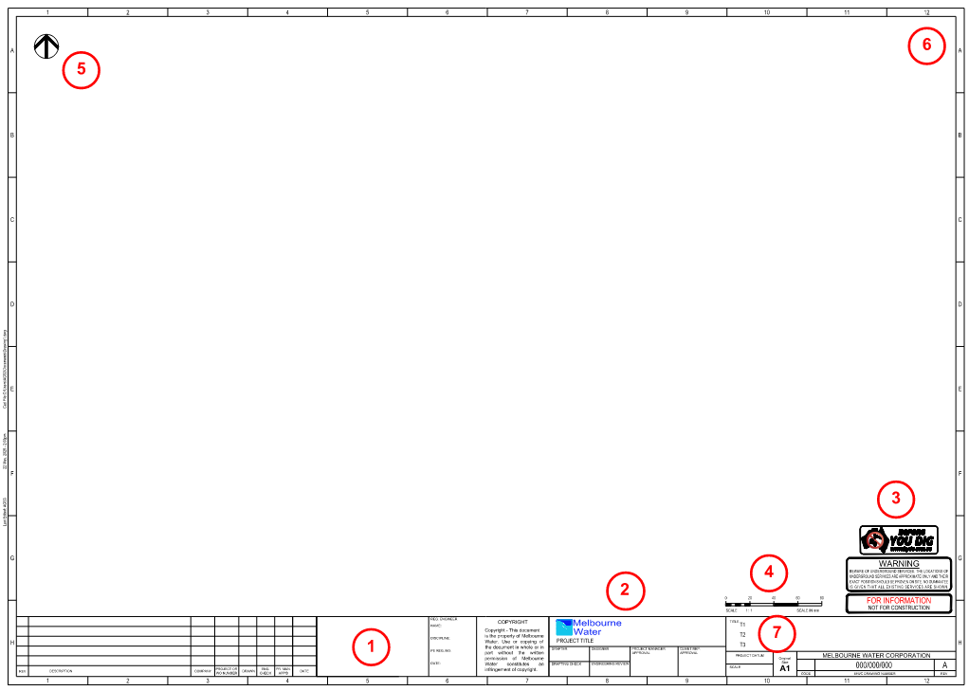
The standard MWC title block has the following features:
- Space for Consultant logo – NOTE: No OLE objects should be attached to CAD files.
- MWC logo converted into CAD linework in the title block Xref file.
- Standard plot status, services warning and Before You Dig Australia stamps to be used on an “as needed” basis – NOTE: No OLE objects should be attached to CAD files.
- The centre marks on “defpoints” layer for scale bars to be inserted on.
- A north point with background mask.
- Space reserved for QR Code in Top Right. Guidance marks on “defpoints” layer.
- Title block content should be as follows:
  - T1 = Location and Asset name
  - T2 = Scope area description
  - T3 = Drawing type

The model space of all drawings shall be set to World UCS with North orientated up the page and the angle rotation to be clockwise.
Unless specifically outlined, or by nature of the project, Paper Space viewports should be oriented with the North orientated up the page or if required, the right of the drawing sheet.
The north arrow should be placed in the upper left-hand corner of single plan drawings. If project north varies from true north, this variation should be shown on the plot plan and key plan only. Other plans shall use project north and note this on the north arrow.

Project Folder Structure

Non Autodesk Construction Cloud Workspace
During project delivery, the Subconsultant shall setup a working folder structure to conform to ISO 19650 principles, namely:
- WIP (Work In Progress)
- Shared
- Published
During deliverable completion for a project the suggested Folder Structure to be used by CAD is as follows:

At a suitable project milestone, or the completion of a project, the entire project directory should be zipped up and issued to MWC. The MWC Project Manager should check that the data and/or design files are suitable and save the relevant files to the related entries in RedEye.

WIP (Work In Progress) Directory
To be used for all “Work In Progress” data, including native CAD files, under the following structure:
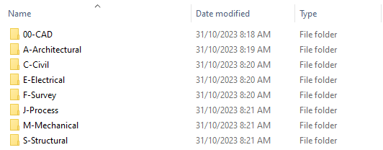

The WIP “00-CAD” directory should be broken up into directories to suit design packages and storage of associated files:
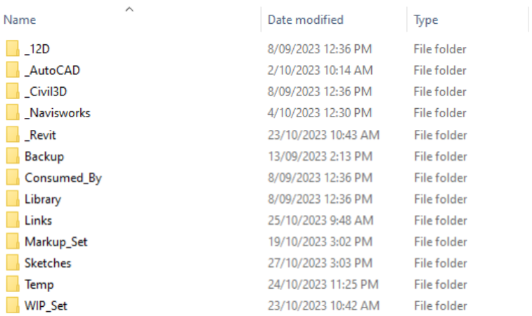

Shared Directory
To be used for all data/designs shared with other disciplines, subconsultants or organisations as part of project delivery. The shared data/designs should be stored under dated directories under the following structure:
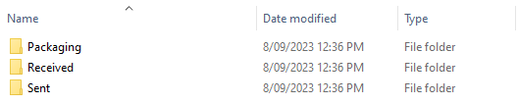

Published Directory
To be used for storage of all data/designs issued as part of a milestone project delivery. The published data/designs should be stored under dated directories with a description of the project phase:


Dated Directories
All dated directories are to be specified as YYYY-MM-DD (dash between) which allows directories to be correctly sorted by date.

Autodesk Construction Cloud and Plant 3D Workspace
Autodesk Construction Cloud is currently being assessed for implementation by MWC. Until this is approved for use, all Plant3D projects shall use the MWC standard operating procedure.
To facilitate an online collaborative design space, Autodesk Construction Cloud should be utilised for project delivery. The Subconsultant shall setup the “Docs” part of this space to conform to ISO 19650 principles, namely:
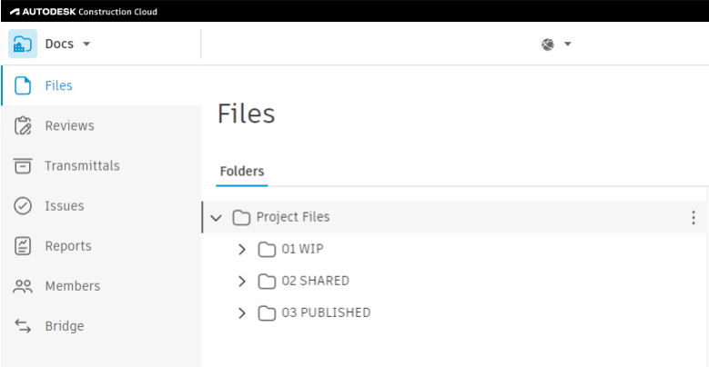
Each folder (WIP, Shared and Published) should be setup to facilitate the various disciplines completing scope for the project, as well as the project milestones.

Plant 3D workspace using ACC
Plant 3D is a design package utilised for drafting of process scope (PFD’s and smart P&ID’s) and the 3D modelling of mechanical scope (Equipment and Piping). Once the project space has been created in Plant 3D, the user can upload it to the ACC project area (if approved by MWC) to facilitate a collaborative environment. To share a Plant 3D project to the cloud:
Note: Plant 3D project names should not include special characters such as (‘, ?, ! etc).
- Open the Plant 3D project you want to share to ACC.
- On the ribbon, click Collaborate tab > Plant Collaboration panel > Share Project
- In the Collaboration for Plant 3D dialog box, click Get Started.
- If you’re not already logged in to Autodesk Docs, sign in using your Autodesk ID and password.
- A drop-down list shows the Autodesk Docs accounts you belong to. Select the Autodesk Docs project folder you want to work on.
- Click Upload Project – A prompt about the successful upload to cloud is displayed.
- (Optional) Click Invite my Team to invite or add more team members.
- Click Close to start working in your cloud project.
Note: The icon next to the uploaded project is changed to indicate that it is a collaboration project.
A MWC project completed in Plant 3D will remain in this workspace. At a significant project milestone, or project completion, the workspace should be backed up and zipped and delivered to MWC. The MWC Project Manager will then ensure that the RedEye elements are linked to this file.

Project Naming Convention

Project Number in
MWC Project Numbers shall be created in Maximo by the MWC Project Manager. It is also the responsibility of the MWC Project Manager to reserve the appropriate drawing numbers for upload to RedEye as part of their project. Refer to AM QRG RedEye Document Drawing Reservation for details. The project group in RedEye will be created by the RedEye BAU Team, for which project manager will need to raise a Service Request. Refer to Service Now for the request form.

Drawing Number Convention
At the start of a project, the drawing number convention to be used will be provided to the Subconsultant by MWC.
All drawing numbers will be reserved and assigned by the MWC Project Manager. Refer “PM SPEC Exchange Information Requirements” and “AM QRG RedEye Document Drawing Reservation”.
Dependant on project setup, the subconsultant/contractor shall fill in associated metadata in RedEye for each deliverable. Refer “PM SPEC Exchange Information Requirements”.

Discipline Codes
A – Architectural Drawings
C – Civil Drawings
E – Electrical Drawings (including loop and instrumentation drawings)
F – Feature Survey Drawings
G – General Drawings
J – Process Piping and Instrumentation Diagrams (P&IDs) & Process Flow Diagrams (PFDs)
M – Mechanical Drawings
S – Structural Drawings

CAD Filename Convention
The CAD and PDF plot filenames shall conform to the drawing number convention provided by MWC.
The convention relating to the use of Multi-Sheet CAD files is being reviewed and assessed by MWC. Until further advice, Multi-Sheet CAD should not be used in MWC projects.

Xref Filename Convention
Reference files are to be named descriptively and logically to ensure that anybody can recognise its contents in relation to the project. In addition to the drawing number convention described above, Xref files should have an “X” added to the discipline code.
For example:
Original Filename | Filename Description | Xref Filename
XXX-C-XXX.dwg | DN600 Pipeline alignment | (Project Number)-XC-DN600 Pipeline Alignment.dwg

Drawing Templates
The standard MWC title block template can be found on RedEye here RedEyeDMS - GS/TBK/001. Download the zip file for all associated configuration files, in AutoCAD format. The level of effort to incorporate any updates to legacy deliverables will be assessed by MWC prior to the engagement.

Drawing Revision
The Title block names and dates shall not be changed from the first “As Constructed” issue, Revision A. The Title block revision letter and the Revision block shall be updated for all subsequent “As Constructed” revisions B, C, D etc.
If an existing drawing is reserved for modification as part of the project and its revision is “B”, the modified drawing delivered to Melbourne Water will be revision “C”.
Where drawings have used numeric order revisions in the past, any future revisions to these drawings should now be indicated alphabetically using the next available letter (i.e. Rev 3 will be followed by Rev D).
Numerical (all revisions prior to “As Constructed”) or Alphabetical (from As Constructed onward) revision shall be updated on the drawing title block and revision block. A brief description of the revision(s), project number, names and date of issue should be updated.
All construction revisions (0, 1, 2 etc) shall be removed from the revision block, prior to delivering new “As Constructed drawings”.
NOTE: Melbourne Water only accepts “As Constructed” drawing revisions into RedEye DMS, which are alphabetical A, B, C etc. Revisions letters I, O & X shall not be used.
Numerical revisions 0, 1, 2, 3….can only be used for preliminary and construction revisions, and will not be accepted into RedEye DMS for “As Constructed” deliverables.
Revision Number | Revision Issue
Numerical (0, 1, 2… etc.) | Preliminary, Tender or Construction Issue
Alphabetical (A, B, C…. etc.) | As Constructed (uploaded to RedEye)

Revision Cloud
First release “As Constructed” drawings (Revision A) must not contain any revision clouds.
When an existing drawing has been revised for issue, a Revision Cloud and Triangle shall be drawn around each amendment in Paper Space on the “REVISION_CLOUD” layer.
Previous revision clouds and triangles to be removed, prior to applying new revision clouds.
A standard revision cloud and triangle style is available in the MWC_A1_Template.dwt CAD template.

Recording Revisions
Only “As Constructed” drawings shall be issued to Melbourne Water. As MWC drawings may be revised across different projects, the Project Number is to be recorded against each revision description or in the provided location in the revision box.

Drawing Transmittal and Project Delivery
This section is to be read in conjunction with AM PRO Preparation of Drawings document. At identified project milestones or end of project delivery, all drawings must be uploaded to RedEye. All design CAD information/data sharing and project delivery should conform to the latest ISO 19650 standards.
Any drawing created using an Autodesk product which does not utilise the ACC environment is to be issued digitally as follows:
- The client representative/MW Project Manager to raise a RedEye Drawing Submission request on the MW Service Portal using the “RedEye Group Creation and Reservation Form” for all “As Constructed” drawings. Refer to the “AM QRG RedEye Document Drawing Submission”.
- For smaller projects (20 drawings or less), all files (Xrefs and drawings) are to be checked back into RedEye.
- For larger projects (more than 20 drawings), the subconsultant/contractor shall upload all files to the MWC input folder (M:\MEL\Info Systems\Drop Box). Create a project folder within the above parent folder (without subfolders), and load all the files (Xrefs and drawings) under that single project folder.
In all cases, the reference (Xref) artifacts must be uploaded into RedEye first. Once completed, the drawing file should be checked in. The RedEye Project Group Administrator shall fill in all associated metadata in RedEye.
For cases where the native Civil3D CAD file (such as a lidar data, data links etc) needs to be transmitted via an eTransmit ZIP file or the transmittal contains PDF’s, these files shall be uploaded to the MWC input folder (M:\MEL\Info Systems\Drop Box).
Any drawing created using the ACC workspace, inclusive of Plant 3D, shall remain in the Plant 3D workspace. At a significant project milestone or project completion, the Plant 3D workspace shall be backed up in a zip file and transmitted to MWC via the MWC input folder (M:\MEL\Info Systems\Drop Box).

Drawing Stamps
This section shows and details drawing stamps to be used on drawings, after input from MWC. For example:
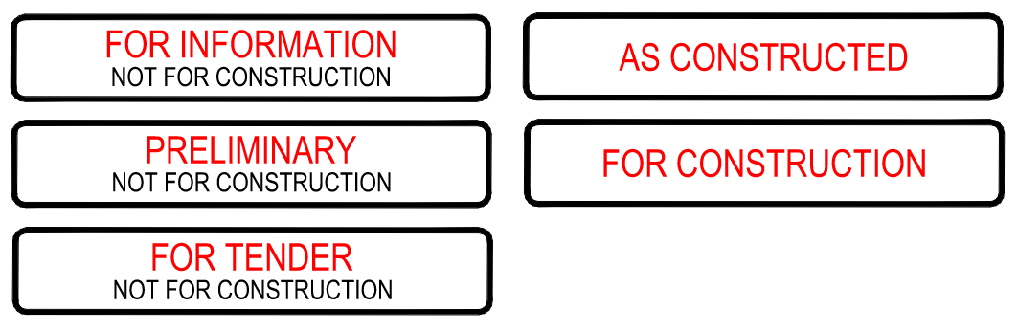

Drawing Scales
All modelled elements drawing in Model Space shall be drawn at a 1:1 scale.
An adequate viewport scale shall be chosen to ensure legible, uncluttered drawings, which meet the recommendations of AS1100 or relevant industry standards. The MWC Design Manager shall approve any viewport scale that is not a multiple of 10 of the following standard scales:
- 1:1
- 1:2
- 1:5
The viewport scale in the paper space is to be nominated in the designated title block location. The scale used must be represented in the body of the drawing. Where more than one scale is used, the relevant scale should be shown under each section, detail etc. Where there is a single scale used on a drawing, it is to be nominated on the title block. When there is more than one scale used on a drawing, “AS SHOWN” should be entered in the designated title block location.
Where longitudinal sections are drawn on the same page as the plan showing the alignment, the same horizontal scale applied to the plan should be applied to the longitudinal sections. The following horizontal/vertical exaggerations shall be applied to longitudinal sections:
- 2:1 (I.e. H 1:100, V 1:50)
- 5:1 (I.e. H 1:500, V 1:100) (Preferred)
- 10:1 (I.e. H 1:500, V 1:50)
Where different scales are used for horizontal and vertical dimensions, each scale shall be clearly indicated.
If a drawing is not to scale or a non-standard scale is used, the letters ‘NTS’ or ‘Not to Scale’ should be inserted where the scale would normally feature.
Standard scale bar blocks are available in the *.dwt template.

Drawing Units
Drawing units are generally dictated by each discipline, as a guide:
Survey models 1 unit = 1 metre (1m)
Civil models 1 unit = 1 metre (1m)
Structural models 1 unit = 1 millimetre (1mm)
Mechanical models 1 unit = 1 millimetre (1mm)
Architectural models 1 unit = 1 millimetre (1mm)
All survey and civil drawings involving set-out or site coordinates shall have units set to North orientated up the page and clockwise angle. The Design Lead shall ensure this is set in the title block template file for the project.
By default, all drawings shall have their insertion scale set to “unitless”.
INSUNITS = 0 (Autodesk product command)

Datum and Coordinate Requirements
Any drawing showing set-out coordinates shall include, at a minimum, a note referencing the relevant survey drawing with the coordinate and height datums, and survey control points (TBMs, PMs etc.). Unless required otherwise by the formal contract, chainages shall increase from left to right across the drawing sheet and shall be read from the left side of the sheet.
- MWC’s standard Geocentric Datum of Australia (GDA/MGA) to be used is 2020. This should be confirmed with the MWC Project Manager for every project.
- All elevations to be provided to the Australian Height Datum (AHD).
In situations where you are required to rotate your external references in designs, use the UCS command or otherwise, so GDA/MGA coordinates are maintained.

Line Type Scales
The following scale settings shall be made to ensure linetypes are shown correctly in Paper Space viewports:
LTSCALE = 1 (Autodesk product command)
PSLTSCALE = 1 (Autodesk product command)
MSLTSCALE = 1 (Autodesk product command)
MEASUREMENT = 1 (ie set to Metric by default) (Autodesk product command)
All linetypes are to be assigned by layer, ie: CELTYPE = “BYLAYER” (Autodesk product command). Layers and associated linetypes are available in the *.dwt template.

Colours and Pen Assignments
To accommodate the majority of mono/colour plotting requirements the following standard pen assignments and corresponding plot styles shall be followed (Note the following image is in colour):
CTB filename: “MWW-PSTYLE-A1.ctb”
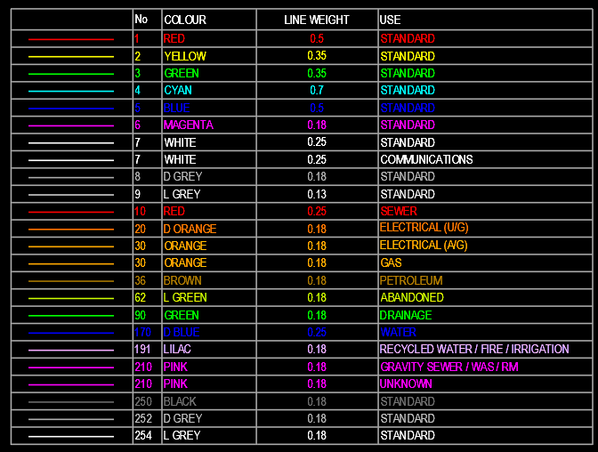
All pen weights are to be assigned by layer, ie: CECOLOUR = “BYLAYER” (Autodesk product command).

Layers/Level and Layer Naming Convention
Layers shall be as per the MWC standard template (*.dwt) file. Nothing may be produced on Layer 0.
All items shall be drawn on the most appropriate layer.
Layer naming shall conform to the MWC Layer Naming Convention (as shown in the template file), unless otherwise agreed with MWC. Where a project specific Layer Naming Convention is to be used on a project, the Lead Designer shall seek approval from MWC prior to implementing. The Lead Designer shall fully document the convention in the project folder and make aware to all staff working on the project.
Colour and linetypes shall always be set to “BYLAYER”.

Text Styles
Project related text shall be inserted into the project drawing in Layout/Paper Space. Use the standard templates to ensure that the correct text styles and layers are used.
The text style used for all project related text is Arial Narrow. The height of text will be as per the following table and depend on its use:
Style
Font | Arial Narrow | Arial Narrow | Arial Narrow | Arial Narrow | Arial Narrow
Plotted Height | 1.8mm | 2.5mm | 3.5mm | 5.0mm | 7.0mm
Layer | TEXT_18 | TEXT_25 | TEXT_35 | TEXT_50 | TEXT_70
Colour Settings
Colour | 6  (Magenta) | 7  (White) | 2  (Yellow) | 1  (Red) | 4  (Cyan)
A1 Plot Weight | 0.18 | 0.25 | 0.35 | 0.5 | 0.7

Dimensions
Dimensions shall be created to MWC standards, set on layer “DIMENSIONS”, using dimension style Standard with text size at 3.5mm.
For creation of dimension annotation DIMASSOC shall be set to 2 (Autodesk product command).

Text Annotation
Generally, annotation such as hatching, and symbols must be placed on separate allocated layers in Model Space.
Generally, annotation such as text, dimensions, revision clouds, hold clouds, notes, legends, tables, schedules, etc. must be placed on separate allocated layers in Paper Space.
No annotative text, blocks, hatching, or other objects are to be used in MWC drawings.
The orientation of all text shall be placed to be read from either the bottom or right-hand side of the drawing sheet.
UPPERCASE letters shall be used for all text annotation on the drawing and in the title block.
Lowercase characters shall be used for conventional signs and symbols where required, such as mm, kg, kPa.
Abbreviations such as & and RD shall not be used on the drawing or in the title block. All text is to be written out in full as in AND and ROAD.
Underlined characters shall be avoided (except for drawing and detail titles).
5mm text used for titles and call-ups shall be underlined.
All characters on a drawing shall be kept clear of lines where practicable.
For creation of Mleader annotation DIMASSOC shall be set to 1 (Autodesk product command).
All text annotations shall be left hand justified and of heights to the following table:
Recommended Minimum Height of Characters on Drawings | Character Height (mm)
Recommended Minimum Height of Characters on Drawings | A1 Sheet Size
Titles and drawings numbers, view detail and section titles | 5.0
Subtitles, headings, section and detail call-ups | 3.5
General notes, text, material lists, dimensions etc. | 2.5
Survey Points | 1.8

Text Masking
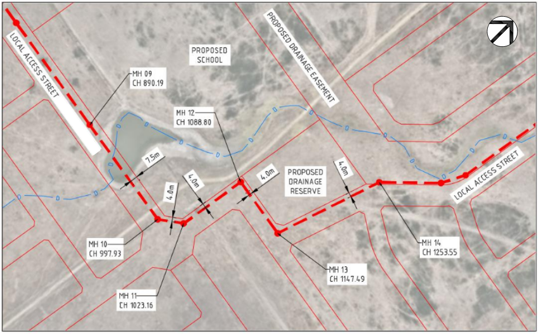
Where text and leader annotation is shown over an aerial image, it shall include a background mask with a distance of 1.5mm.
Careful attention should be made to not overlap any design features with background masked text.

Example of Text Alignment
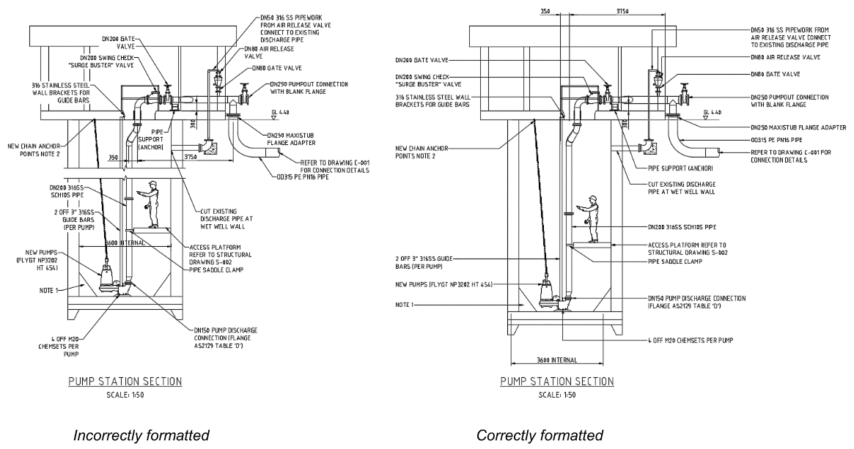
The preferred annotation arrangement for general drawings is shown on the detail above:
- Mleader annotation positioned to not overlap or cover any linework.
- Mleader annotation correctly left justified and aligned vertically where practicable.
- Dimensions positioned away from the baseline object.
- Mleader annotation may, where nothing else is practicable, run through dimension extension lines. Mleader annotation should never cross through the dimension baseline.
- Mechanical and Structural overall section drawings should, where practicable, never be cut as it is better to show the full section. This may mean showing plans and sections on different sheets.

Standard Layers and Linetypes
MWC standard colours, layers and linetypes shall be used to produce project drawings and models. MWC Project Manager discretion may be used for project specific deviation of these standards.
The MWC standard colours are below, however where a project requires additional colours the MWC Project Managers discretion shall be used:
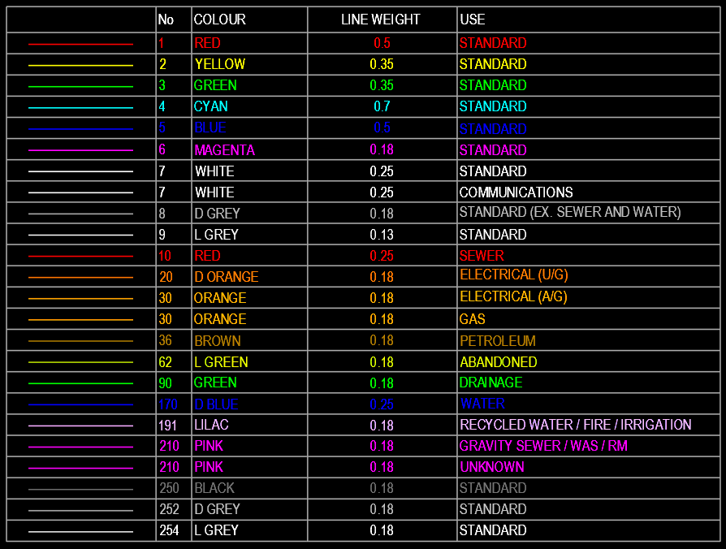
Colours for other services (i.e. electrical, gas, communications etc.) shall use the above chart. Linetypes for these other services are available in the MWC template (*.dwt) and are listed in Appendix A.
Linetypes and colours for Water and Sewer services shall follow MRWA standards. Proposed or new Water services shall be shown in Blue, proposed or new Sewer services shall be shown in Red.

Sections and Details

Sections
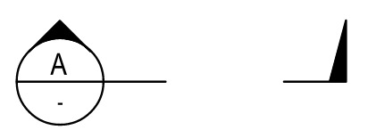
The following requirements apply to sections:
- Capital Letters shall be used for sections.
- Where possible, sections should be directed towards the top or left of the drawing sheet and positioned to read in third angle projections.
- As far as possible, section drawings shall be drawn on the sheet on which they are cut if they are to the same scale.
- Preferably, sections should be cut from the plan views. Avoid cutting any major section from another.
- Section letters shall not be repeated on the same drawing (i.e. there is only one section A per sheet).

Details
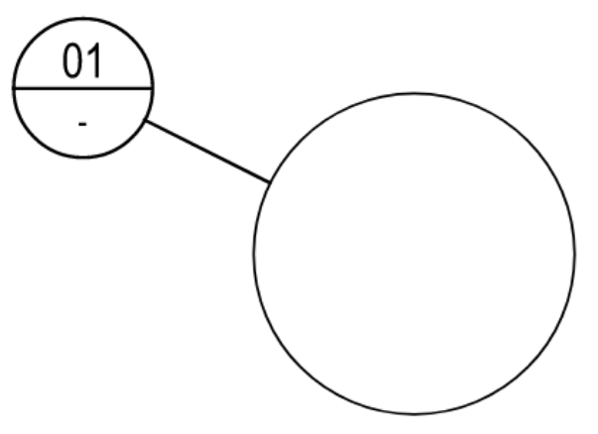
The following requirements apply to details:
- Numerals shall be used for details and include leading zeros, i.e. 01, 02, 03 etc.
- Detail numerals shall not be repeated on the same drawing (i.e. there is only one detail 01 per sheet).

Section and Detail Markers
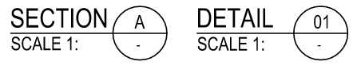
The following requirements apply to markers:
- Each section and detail marker shall contain the drawing number from which the section or detail is referenced.
- When the section or detail view is drawn on the same sheet, a dash shall be used in lieu of the drawing number.

Obsolete or Superseded Drawing
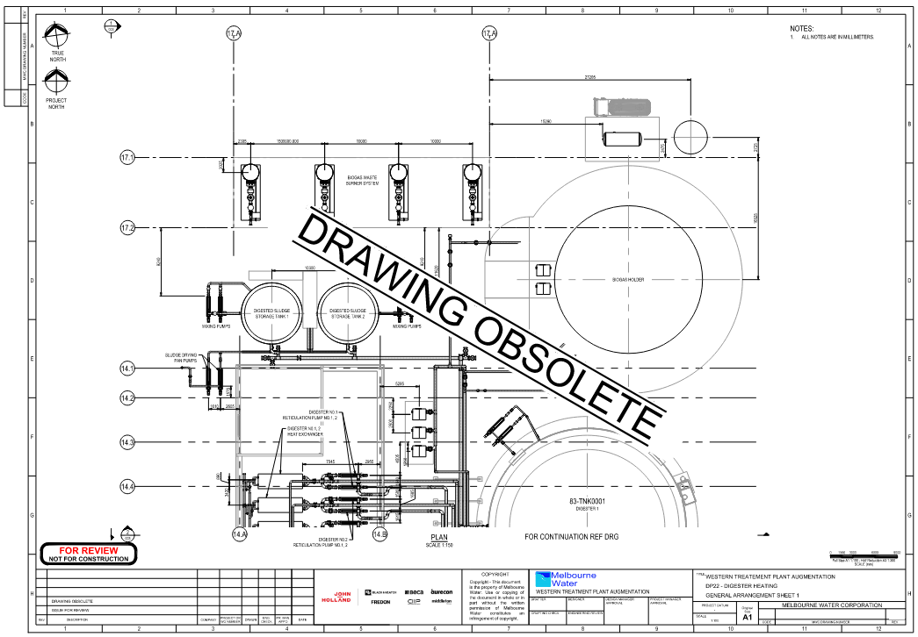
If a drawing has been formally issued but has been become redundant it should be revised with the words DRAWING OBSOLETE or DRAWING SUPERSEDED in 25.0mm bold text across the middle of the drawing on an angle between two parallel lines (refer example above). The drawing shall be given the next revision number and have “DRAWING OBSOLETE” or “DRAWING SUPERSEDED BY DRG XXX” written in the revision history box for Description.
A drawing shall only be made obsolete when the entire scope shown is removed from site. If any shown scope is decommissioned or abandoned (but remains on site) the exact extents shall be reflected on the current project drawings and documents.
A document transfer notice shall be updated to inform all parties of an obsolete or superseded drawing. The preference is to issue the drawings that were made obsolete or superseded to the parties that normally receive the drawings, after which the drawing is retired from future issue.
If a drawing is made obsolete or superseded, the drawing number should not be re-used and is retired. The drawing shall remain as such in the RedEye system.

Use of External Drawings and Survey Data
Where an external party’s CAD files are being used as input to project design, such as vendor equipment drawings/models, survey or site drawings, the following procedure should be followed:
- Received native CAD files saved under the Shared> Received location under a dated directory with appropriate description.
- User to copy the original supplied CAD file to WIP > 00-CAD > Links and rename the file as per a reference file. Reference files are to be named descriptively and logically to ensure that anybody can recognise its contents in relation to the project. In addition to the drawing number convention described previously, Xref files should have an “X” added to the discipline code. For example:
Original Filename | Filename Description | Xref Filename
XXX-F-XXX.dwg | Feature survey | (Project Number)-XF-Feature Survey.dwg
- When received survey data includes subsurface utility quality levels (A to D) as per AS 5488 Part 1 and 2, this data must be retained when Xrefed into project design files.

GIS Data Importing and Exporting
The GIS data importing and exporting procedure is currently being reviewed and assessed by MWC. At the start of a project, MWC will confirm the systems to be used by the subconsultant.
Some of the available methodology includes (but is not limited to):
Importing of GIS data from MWC system into Civil3D design files will be done via *.SHP (ShapeFile) files. Ensure that the three required files that makeup the shapefile (*.SHP, *.SHX and *.DBF) are saved in the appropriate location.
Use of GIS data hosted on ArcGIS shall be imported directly using the Autodesk Connector for ArcGIS.
Exporting of data from project design files for input into MWC GIS system shall be at predetermined project milestones. Appropriate verification must be conducted to ensure the accuracy of this data. This export will be done via a ShapeFile format.
Where available, a direct export of project data to MWC GIS system shall Use the Autodesk Connector for ArcGIS.

Drawing Re-Numbering
Re-numbering of drawings shall be avoided in all cases after any external issue.

Process and Instrumentation Diagrams
Process and instrumentation diagrams (P&ID’s) should be drafted using MWC Plant 3D system detailed by the standard operating procedure.
Refer to Appendix C for the current P&ID Legend Sheets.

References
Document title
AM PRO Preparation of Drawings Document
AM SOP AutoCAD Plant 3D Project Management
AM TEM Drawing Register
AM TEM Transmittal Note

Appendices
Appendices
Appendix A – MWC Services Linetypes
Appendix B – MWC Drawing Border and Standard Blocks
Appendix C – MWC P&ID Legend Sheets

Appendix A – MWC Services Symbols and Linetypes
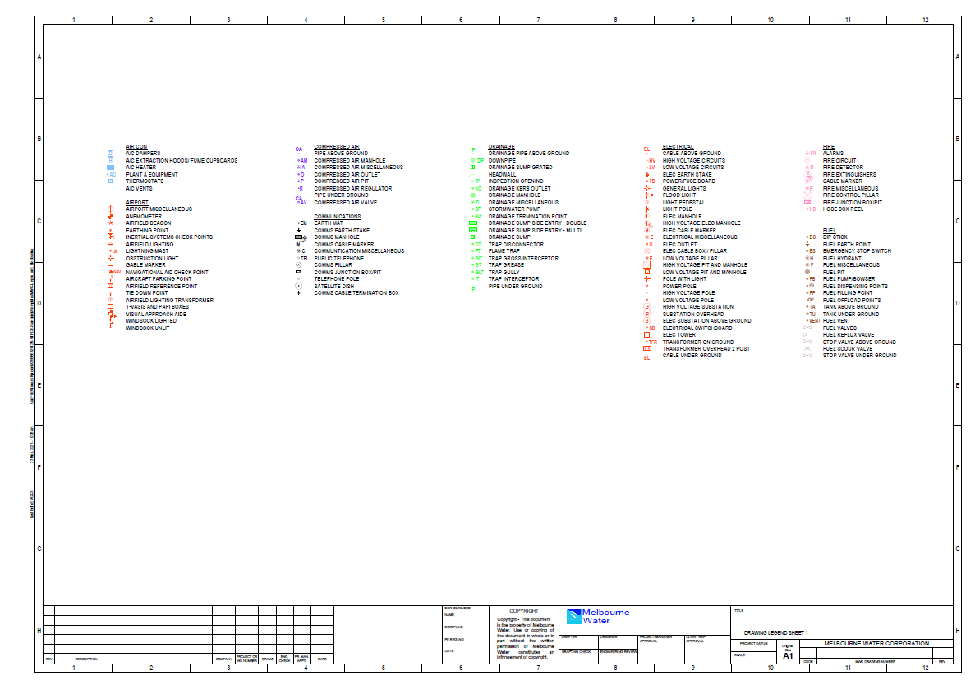

Appendix B - MWC Drawing Border and Standard Blocks
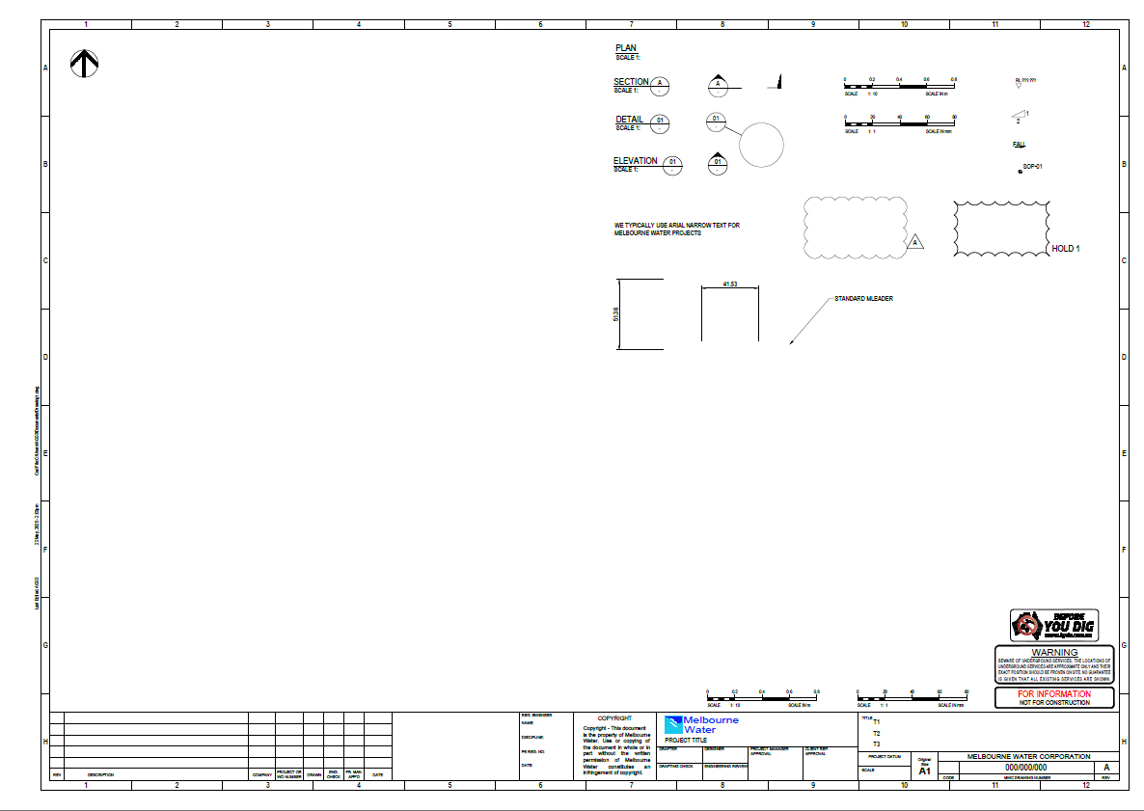

Appendix C – MWC P&ID Legend Sheets
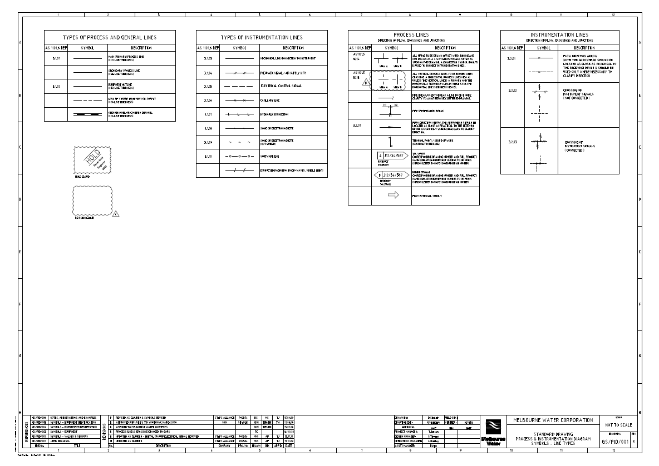

Will require RedEye access to view the links below:

RedEyeDMS - GS/PID/001 (PDF image above)
RedEyeDMS - GS/PID/002
RedEyeDMS - GS/PID/003
RedEyeDMS - GS/PID/004
RedEyeDMS - GS/PID/005
RedEyeDMS - GS/PID/006
RedEyeDMS - GS/PID/007

Stakeholder Consultation
Stakeholders
Asset Knowledge And Technology
Technical Services
Service Enablement
Service Programs
BECA Engineering Group

Document History
Date | Reviewed/  Actioned By | Version | Action
July 2025 | Data Administration Officer/ Reporting And Data Lead | 3 | Document updated.
November 2024 | CAD Consultant | 2 | Document review.
December 2023 | CAD Consultant | 1 | First published version.

