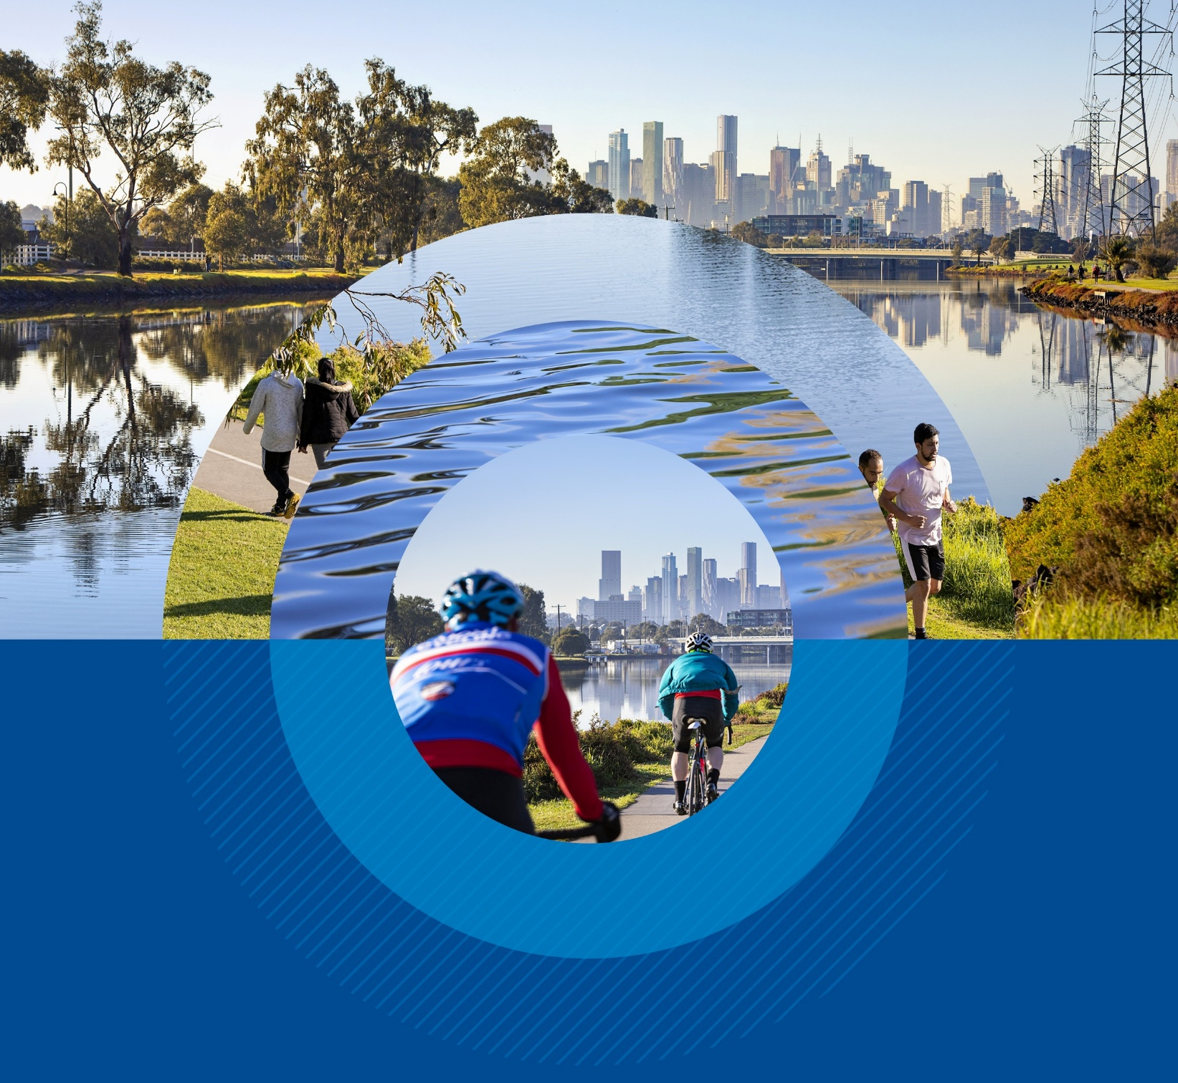


Phase 2 – Engagement Summary

Maribyrnong River catchment flood mitigation study

March 2026
Acknowledgement of Country
Melbourne Water respectfully acknowledges Aboriginal and Torres Strait Islander peoples as the Traditional Owners and custodians of the land and water on which all Australians rely.
We pay our respects to Bunurong and Wurundjeri Woi-wurrung peoples as the Traditional Owners and custodians of the land and water of the Maribyrnong River. We pay our deepest respects to their Elders past and present.

Executive summary
This summary provides a brief overview of Phase 2 community and stakeholder engagement for the Maribyrnong River catchment flood mitigation study (the study).
Phase 2 of community and stakeholder engagement for the study took place from October to December 2025 and focused on gathering feedback on:
- The Evaluation Criteria
- The long-list of flood mitigation options (the long-list)
- The engagement process.
This phase provided key insights that will help shape the short-listing of flood mitigation options and will inform how we plan the next phase.

How we engaged
To reach a diverse-cross section of the community across the Maribyrnong River catchment we delivered a mix of online and in-person activities:
  4 community drop‑in  events with  60+ attendees |   3 Community  Partnership Panels with 44 members |   9 small group discussions with 35+ attendees
  120+ surveys completed |   10+ additional submissions via email and written feedback |   Options Map: 160  contributions across  ~50 conceptual options
  Let’s Talk website: 13,700+ views |   Social media campaign: 1.3M+ impressions |   13,000+ letters distributed


What we heard

Evaluation Criteria:

- Community and stakeholder sentiment about the Evaluation Criteria was mixed
- We received a high number of comments on how the categories in the Criteria had been ranked, especially the relative importance of Safety, Property and Value for Money
- Feedback recommended that some of the language needed to be improved to help with clarity, especially terms like favourable and unfavourable
- We received a significant amount of feedback from Kensington Banks residents, asking for the Criteria to reflect local risk, past commitments and issues raised in the Victorian Ombudsman report.


The long‑list of options

Overall, the feedback about the long-list of mitigation options highlighted:
- A clear recognition among community members and stakeholders of trade‑offs between risk reduction, cost, timing, environmental impacts, amenity and feasibility
- We received the most feedback on the following categories of mitigation options:
  - Retarding basins with 91% of feedback agreeing with their broad locations
  - Nature‑based solutions received strong positive sentiment for environmental outcomes
  - Levees: concerns about visual/amenity impacts and downstream impacts
  - Multifunctional storage areas: mixed feedback, with impacts to recreation raised as a key concern
- Some categories (e.g., alterations to bridges) drew questions about effectiveness and practicality
- Community asked for more information about certain emerging or excluded options (e.g., Tidal Barrage, Flemington Racecourse storage).


Engagement process
The survey results from the engagement events showed strong satisfaction:
- 100% found participation and access easy or very easy
- 92% rated events good or excellent
- 70% found materials easy to understand.

Introduction
In Phase 2, engagement focused on gathering feedback about the Evaluation Criteria, the long-list and the engagement process. This summary provides an overview of engagement in Phase 2. Including, how we engaged, what we heard and what’s next.
Together with the community, Melbourne Water is exploring flood mitigation options to help reduce flood risk for the lower Maribyrnong River catchment. The study forms part of the work needed to identify, develop and implement flood mitigation options that will help to reduce flood risk while also reflecting community values as much as possible. To learn more about the study, please visit the Let’s Talk website: letstalk.melbournewater.com.au/maribyrnong-mitigation
Phase 2 of community and stakeholder engagement for the study took place from October to December 2025. It focused on gathering feedback on the Evaluation Criteria and the long-list of flood mitigation options. Additionally, we asked community members for feedback about the engagement process.
To learn more about the Evaluation Criteria, please visit the Let’s Talk website: letstalk.melbournewater.com.au/evaluation-criteria To view the long-list of options in full, please see the long-list handbook, available on the Let’s Talk website: letstalk.melbournewater.com.au/maribyrnong-long-list
Feedback collected during Phase 2 has provided the study team with valuable information about community and stakeholder preferences for the Evaluation Criteria and the long-list. This feedback is being considered by the study team as part of the shortlisting of flood mitigation options. We will share the shortlist as part of Phase 3 of the study. Additionally, we are considering the feedback about how we undertook the engagement for Phase 2 to inform how we will deliver Phase 3 of engagement for the study.
A note that this summary includes direct quotations from members of the community. Where these quotes have been used this is indicated with the use of quotation marks (e.g., “ ”).
Please note that whilst the study team are considering all feedback on the specific options, in this summary we have grouped this feedback under mitigation option categories to reflect the common themes.
All feedback included in this summary is anonymous.
The study team and Melbourne Water would like to extend our appreciation to everyone who contributed feedback in Phase 2, thank you for your time and participation.

How we engaged
Aiming to connect with as many different members of our community as possible, across the whole Maribyrnong River Catchment, Phase 2 of community and stakeholder engagement involved a variety of online and in-person activities and events.

Community drop-in events
 | 4  Events | 60+  Attendees
We engaged with the community at drop-in events held in Sunbury, Kensington, Darraweit Guim and at the Rivervue Retirement Village. The events were attended by members of the study team, including subject matter experts from Melbourne Water and Jacobs to provide an opportunity for community members to learn more about the study and to ask questions. Some attendees chose to provide feedback during the events using paper-based surveys, on the physical maps and also via the Options Map (a digital map).
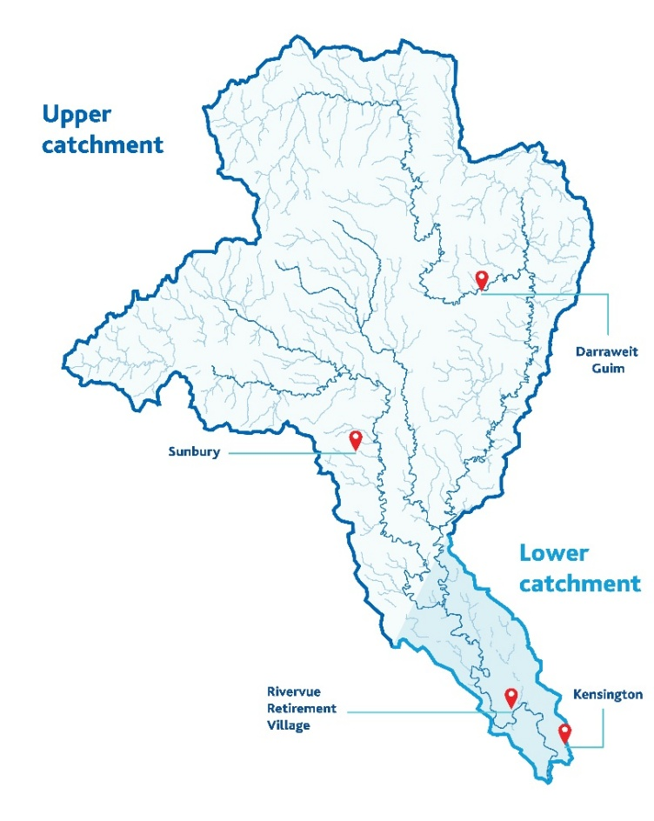
Figure 1 Map of locations for Phase 2 drop-in events
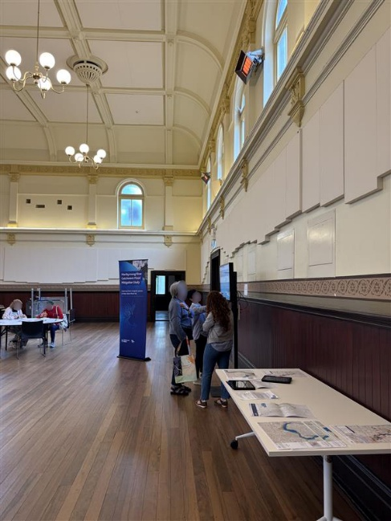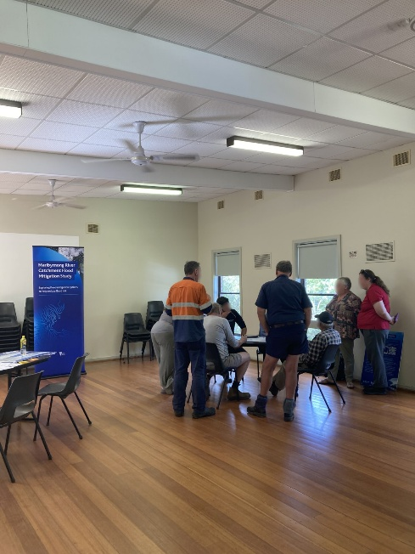
Image 1 Attendees at community drop-in events

Community Partnership Panels
 | 3  Panels | 44  Members
We hosted the second round of Community Partnership Panels (Panels) for the study in Phase 2. The Panels were made up of a consistent group of members who live or work in the catchment area and are collaborating with Melbourne Water. They provide feedback on an ongoing basis over the course of the study. Feedback received during the Panels is detailed in the Phase 2 Community Partnership Panel Feedback Report, available on the Let’s Talk website: letstalk.melbournewater.com.au/maribyrnong-cpp
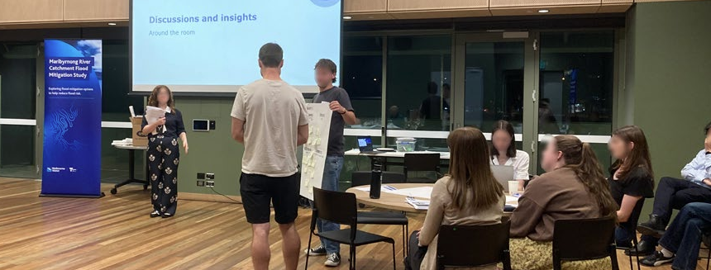
Image 2 Members sharing feedback at a Community Partnership Panel

Let’s Talk website
 | 13,700+  Views
Over the course of Phase 2, we posted regular updates and information about the study on the Let’s Talk website. Additionally, we used the platform to host our digital surveys and share information about upcoming events and opportunities to provide feedback, with the page receiving over 13,700 views in total.
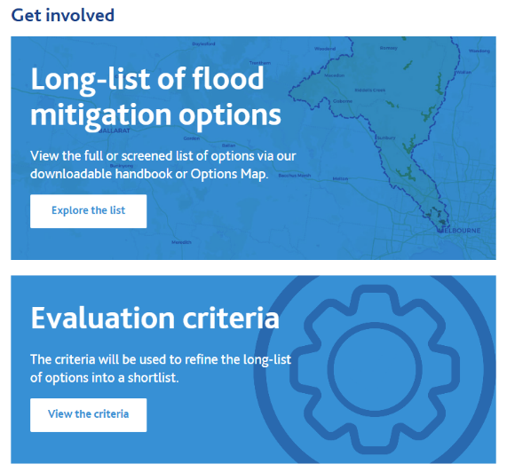
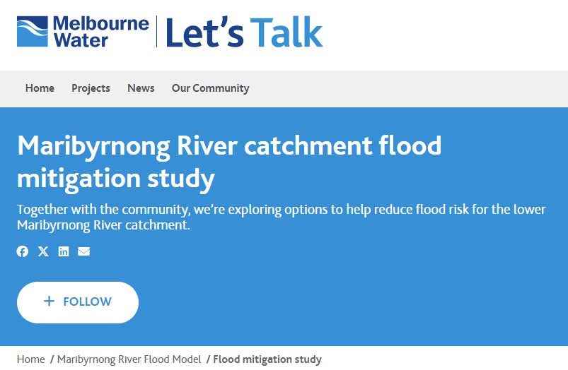Image 3 The study page on the Let’s Talk website

Small group discussions
 | 9  Meetings | 35+  Attendees
We held nine small group discussion meetings with government agencies, private organisations and community groups with an interest in the study, including:
- The Australian Government Department of Defence
- The Kensington Association
- Maribyrnong Catchment Resilience Association
- Maribyrnong City Council Community Recovery Committee and Moonee Valley City Council Community Recovery Committee
- Maribyrnong Rivers and Waterways Association
- Perri Projects
- Rivervue Retirement Village Residents Committee
- Tigcorp
- Victoria Racing Club.

Minutes were taken at most of the small group discussion meetings to capture feedback from attendees. These minutes were shared with attendees for review and approval before being finalised. Many of the key sentiments we heard during the sessions are reflected in this summary, but due to the conversational nature of meetings, we have not included direct quotations from the meetings.

Social media
 | 1.3 million+  Impressions
We promoted the study, opportunities to provide feedback and the community engagement events we held during Phase 2 with a targeted social media campaign, with this content receiving over 1.3 million impressions in total.

Surveys
 | 120+  Completed
Collecting feedback about the Evaluation Criteria, the long‑list and the engagement process, over 120 digital and printed surveys were completed by community members and other stakeholders during Phase 2.
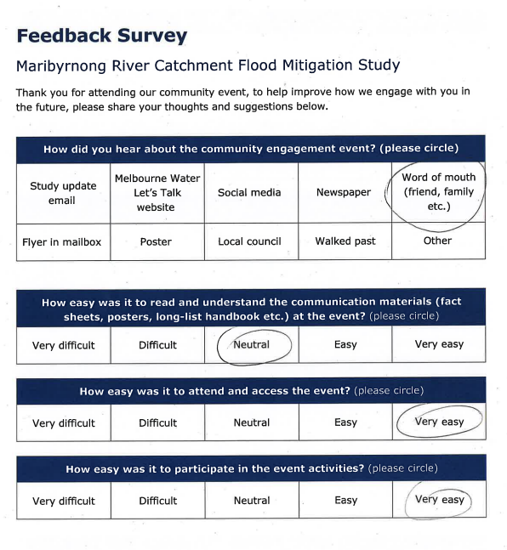
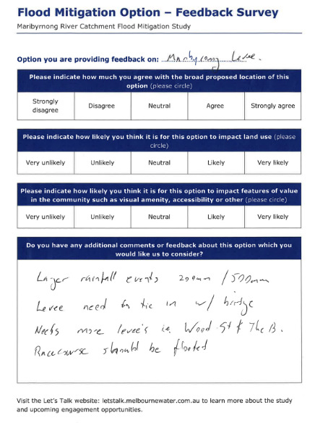

Figure 2 Surveys collecting feedback about different aspects of the study

Letters
 | 13,000+  Homes and businesses
In Phase 2, around 13,000 homes and businesses received a letter from us raising awareness about the study and promoting the various opportunities to provide feedback or to attend community engagement events.
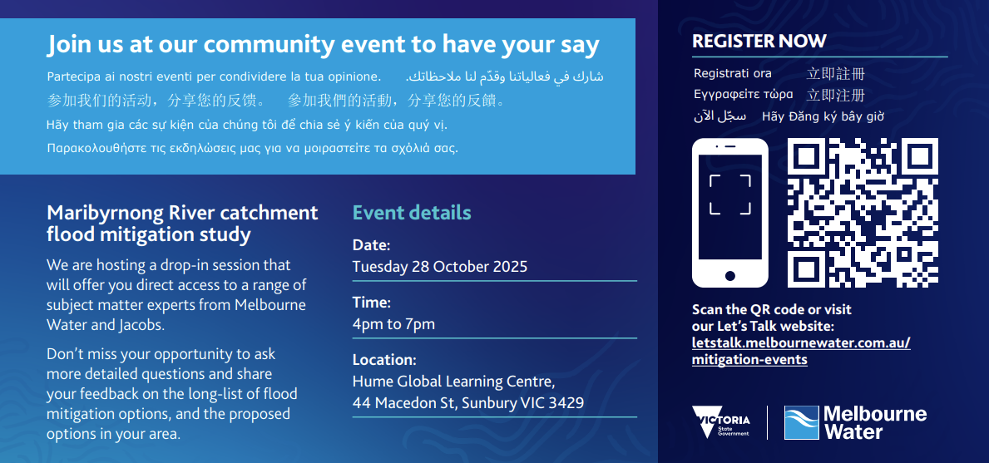
Figure 3 Letter sent to community members promoting a Phase 2 engagement event

The Options Map
 | 160  Contributions
The Options Map displayed approximately 50 conceptual options from the long-list on a digital map of the catchment. As the options on the long-list are conceptual, their location, appearance and other details are subject to change. As such, we displayed the options on the Options Map according to their broad proposed location, or in other words, the general area in which an option might be placed, rather than a fixed or final location.
The Options Map provided an overview of each of these 50 options and collected community feedback about them. A note that some of the 160 contributions received via the Options Map contained identical content. Nonetheless, all contributions are included in this summary.
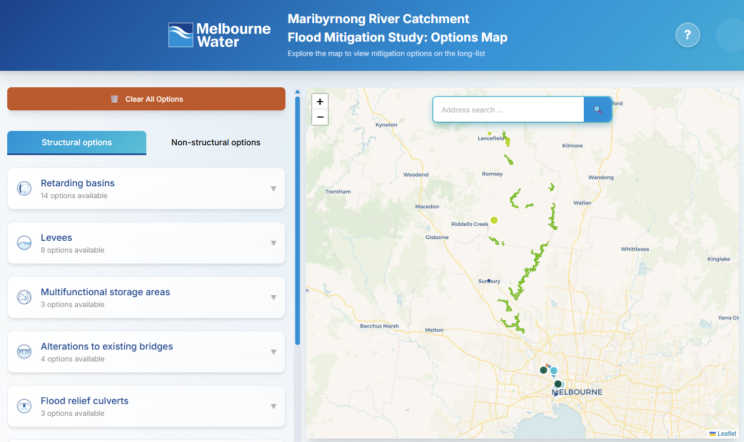
Figure 4 The Options Map, used to display information and collect feedback about the options

Other
 | 10+  Submissions
During Phase 2, the study team received feedback through other types of submissions, including emails and various written contributions. The Maribyrnong Rivers and Waterways Association submitted feedback about the study and the long-list, including suggestions for the locations of additional retarding basin options, among other feedback.
The Maribyrnong Catchment Resilience Association provided feedback about various aspects of the study through emails and a written position paper; including feedback about the engagement process, the study’s technical processes and methodology and calling for the study to “Release a 3D simulation of the 2024 1% AEP Flood Event…”. Further, we heard from various community members via email, with many of the themes raised in these submissions mirroring the feedback we heard more broadly in Phase 2.

What we heard
Phase 2 of engagement provided valuable insights about the perspectives of those in our community in relation to the Evaluation Criteria, the long-list and the study’s engagement process. We have presented a summary of the key themes below.


The Evaluation Criteria

The Evaluation Criteria was developed based on the feedback we received during Phase 1 of engagement for the study. In Phase 2, we asked community members and stakeholders to review the Criteria to help us understand whether it reflected what matters most to them when it comes to reducing flood risk. This phase also provided an opportunity to check in and confirm how well the Evaluation Criteria captured the priorities and concerns raised during Phase 1.
In Phase 3, the updated Evaluation Criteria, shaped by what we heard in Phase 2, will be shared with the community.

Key themes
Overall, feedback collected over the course of Phase 2 reveals mixed perspectives among the community about the Evaluation Criteria. In the Evaluation Criteria survey, we asked two different questions about its ‘accuracy’. One question was about how well it reflects what is important to the community when it comes to reducing flood risk, and another about how well it reflects the feedback provided to us in Phase 1, with the results highlighting a diverse variety of perspectives.
Overall, 49% of survey respondents indicated they think the Evaluation Criteria is ‘inaccurate’ or ‘very inaccurate’. This was largely driven by differing opinions around the ranking of categories and the use of language in the Evaluation Criteria. This is discussed in more detail below. On the other hand, 51% of survey respondents selected ‘neutral’ or ‘accurate’ in response to these questions. It is worth noting that no survey respondents selected ‘very accurate’ for either question.
In contrast to the results of the Evaluation Criteria survey, we heard at the Panels that while the Evaluation Criteria requires some adjustments to better reflect community feedback, members broadly agreed it is mostly accurate. It is worth noting that during the Panels, members considered the accuracy of the Evaluation Criteria as part of a structured feedback activity and had the opportunity to ask questions or discuss it with subject matter experts. Additionally, the Panels provided an environment that allowed for a high degree of information about the Evaluation Criteria to be discussed, including its development and application. It is therefore unsurprising that the feedback collected during the Panels differs from that gathered through the broader community survey. This variety of feedback reveals the diverse expectations of those in our communities and their varying levels of confidence in the Evaluation Criteria.
In addition to feedback received about the ‘accuracy’ of the Evaluation Criteria, much of the feedback we captured in Phase 2 focused on the ranking of the Evaluation Criteria categories, revealing mixed sentiments among the community about their relative importance. Feedback also highlighted the different perspectives among community members about the language used to describe or define the categories in the Evaluation Criteria.

Ranking of categories
Discussions about the ranking of the various categories in the Evaluation Criteria are reflected in many of the responses we received from the community via the Evaluation Criteria survey, particularly in relation to the ‘Safety’ and ‘Property’ categories. For example, some respondents commented that ‘Safety’ should be the category of highest importance, followed by ‘Property’. Conversely, some submissions stated that ‘Property’ should be the category of highest importance, ahead of ‘Safety’.
Several respondents of the same survey also discussed the ‘Value for Money’ category, further revealing diverse perspectives among the community. Some comments indicated general agreement with the ‘Value for Money’ category. While other feedback indicated some community members perceive the ‘Value for Money’ category as flawed. For example, one comment suggested it could disadvantage potentially effective options, if they are considered relatively more expensive.

Comment snapshot
“Safety followed by Property should be priority one.”
“I would put them like this: 1) Property (ultimately we want to keep our homes safe and that they can maintain their value)…”
“The value for money criteria is flawed. There may be an option that is considered expensive (over $100 million) that still provides excellent value for money when you consider the damage a flood will do.”
“I would like Safety and property to be on the same level.”
“…Value for money: makes sense...”

Use of language
Over the course of Phase 2, we heard from the community about a desire for a range of changes to be made to the language used to describe and define the categories of the Evaluation Criteria. In particular, we observed this in relation to the use of terms like ‘favourable’ and ‘unfavourable’ within the Evaluation Criteria.
For example, in relation to the ‘Property’ category, some comments received via the Evaluation Criteria survey suggested that the language used to define ‘highly favourable’ options should be changed so that it includes options which benefit properties across the entire floodplain. Alternatively, other responses to the same survey suggested that the language used to define ‘highly favourable’ options should be updated to include those which benefit the properties of specific communities and small areas of the floodplain which might be more susceptible to flood.

Comment snapshot
“In terms of the property criteria a “highly favourable” option should benefit ALL properties in the floodplain.”
“The current evaluation criteria do not fairly measure property protection. By giving a “highly favourable” score only to options that reduce flooding across the entire floodplain, the framework undervalues targeted solutions that protect high-risk communities like Kensington Banks…”
“The “highly favourable” option for Property criterion should benefit all, not most, properties in the floodplain.”
“…The scoring system gives top ratings only to measures that reduce flooding across the whole floodplain, overlooking targeted, cost-effective solutions that could quickly protect vulnerable communities…”

Other insights
Victorian Ombudsman report
Before continuing with the summary, we wish to acknowledge everyone across the broader Maribyrnong area impacted by the October 2022 Maribyrnong flood event. We also acknowledge the impact on residents following the updated flood modelling released as part of the Maribyrnong River Flood Review into the 2022 flood event. For more information and to read Melbourne Water’s full statement in response to the November 2025 Victorian Ombudsman report, please visit the Melbourne Water website: melbournewater.com.au/about-us/what-we-do/news/melbourne-water-statement-response-victorian-ombudsman-report
Kensington Banks
In response to the Phase 2 Evaluation Criteria survey, we received a significant volume of submissions from members of the community identifying themselves as residents of Kensington Banks. Much of the feedback expressed a desire for the Evaluation Criteria to be changed to reflect prioritised protection for Kensington Banks, including in relation to the Victorian Ombudsman Report. Some respondents expressed the view that Kensington Banks experiences particular flood‑related challenges within the broader catchment and would like to see this reflected in how flood mitigation options are assessed. As part of this, some community members indicated a preference for approaches that could enable earlier or more targeted mitigation for their area.

Comment snapshot
“…Not all properties in the floodplain face the same circumstances. Kensington Banks residents, like me, were explicitly told their homes were safe - this creates a unique obligation that must be reflected in the evaluation criteria…”
“The current evaluation criteria fail Kensington Banks residents, who bought homes believing they were safe from flooding based on Melbourne Water’s assurances. New modelling shows these homes are at risk, raising insurance costs and lowering property values, a breach of trust that demands action…”
“The evaluation criteria needs to prioritise protection for Kensington Banks residents who purchased homes based on explicit advice from Melbourne Water that properties were above flood level...”
“…Please update the evaluation criteria so they prioritise timely, effective protection for Kensington Banks and reflect the responsibilities identified by the Victorian Ombudsman.”

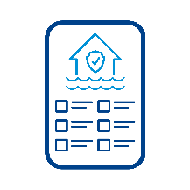

The long-list

Phase 2 involved calling on the community to explore the long-list and asking for their general feedback about the options. The study team sought to understand more about their thoughts, ideas and concerns about the long-list, and about specific options, with the aim of using these insights to help refine the long-list into a shortlist in Phase 3.
Overall, feedback collected about the long-list in Phase 2 revealed a variety of different community preferences about the options and highlighted the many factors that are of importance to the community. The feedback provided an insight into how the community are contemplating the complexities, advantages and disadvantages associated with each option and the many trade-offs which need to be considered during the shortlisting process.

Trends in feedback across option categories
Options in the Retarding Basin category received the highest number of submissions on the Options Map. This was followed by levee options, multifunctional storage areas and nature-based solutions. Figure 5 indicates the different categories of options which we received feedback about via the Options Map, according to the total percentage of contributions for each category of option.
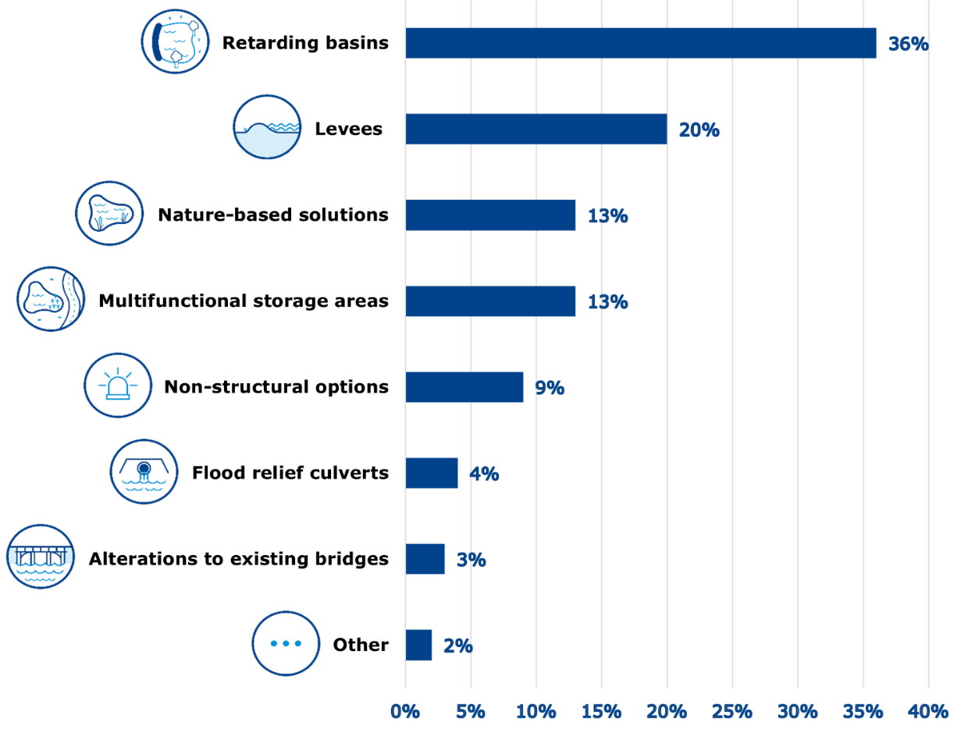
Figure 5 Option categories according to percentage of contributions received on the Options Map
In addition to asking for general feedback about the options, when collecting feedback via surveys and the Options Map, we asked targeted questions to understand more about what the community thinks about specific options in relation to their broad proposed location, potential land use impacts and potential impacts on features of value in the community, as shown below in Figure 6.
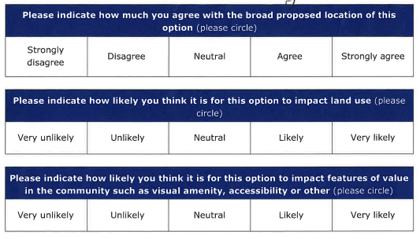
Figure 6 Excerpt of a survey used to collect feedback about a specific option on the long-list
The options on the long-list are conceptual, meaning their location, appearance and other details are subject to change. As such, we collected feedback from the community about the options in relation to how much they agree with their broad proposed locations, or in other words, the general area in which the option might be placed, rather than a fixed or final location.
When asking about land use, we aimed to understand how likely the community think an option might impact how nearby land is currently used. For example impacts to housing, business or industry, or as a place for sport, recreation or for agriculture.
We asked about local features of value to understand how a mitigation option may affect the things community like or value in their local area. For example, features of value might include visual amenity, a favourite local café, green spaces or the accessibility of local parks, roads, public transport or services.


Retarding basins
Across all of the options within the retarding basin category presented for feedback on the Options Map:

91%
of respondents agree or strongly agree with their broad proposed locations
60%
of respondents think potential impacts on land use are unlikely or very unlikely
71%
of respondents think potential impacts on features of value in the community are unlikely or very unlikely

Key themes
In Phase 2 more broadly, feedback about the retarding basin options highlighted that many members of the community are generally positive about their potential and that they would like to see them be further investigated as part of the study. Much of the feedback received also raised concerns about the possibility of negative environmental impacts or potential problems related to interference with existing land use.

Comment snapshot
Arundel (RB70)
“I believe this is one of the best options as it addresses the flood impact on its own.”
“Unsure why this is still being considered as an option. History of floods (i.e. 1975) in the lower catchment, people built on a floodplain. Flood environmentally sensitive areas like Organ Pipes National Park.”
Willow Flat (RB25)
“This seems like a great option but we may need several of these across the catchment to help reduce flood risk in the lower parts of the catchment.”
Lancefield (RB30)
“This storage is required just to manage the urban growth in the area.”
Sunbury (RB20)
“Storage assets like this will be required just to handle the urban growth in the area.”
Beveridge West (RB55)
”Beveridge West will fill up in a flood. As a result, water could push back upstream. Please consider how this will impact the town.”


Levees
For all levee options available for feedback on the Options Map:
59%
of respondents agree or strongly agree with their broad proposed locations
28%
of respondents think potential impacts on land use are unlikely or very unlikely
25%
of respondents think potential impacts on features of value in the community are unlikely or very unlikely

Key themes
Much of the feedback received in relation to levee options in Phase 2 related to the potential for impacts on visual amenity and community amenity, along with suggestions of how these impacts might be mitigated through measures like design choices or recreation features. Additionally, feedback raised concerns about levee options causing negative impacts in other areas and the necessity of limiting this as much as possible.

Comment snapshot

Rivervue Retirement Village (L020)
“This option seems like a good idea to protect properties in the Rivervue site. It is a site specific option but I think it is worthwhile…”
Maribyrnong Township Protection (L030)
“This doesn't seem like a good option. The levee will create a huge barrier between the river and the community.”
Kensington Banks Protection (L056)
“Unlike the other Hobsons Road levee, this one is much further in from the river and looks like it will impact the apartment building and commercial buildings along Hobsons Road/the river to the point of possibly (partially) destructing them or them butting up directly against the levee which seems very undesirable...”
Sims Street, West Melbourne (L070)
“Need to retain river path for walking/cycling and avoid introducing safety hazard (drowning etc) or flooding other residential areas.”
Hobsons Road, Kensington (L054)
“I like the benefits the levee could bring and if the levee was immediately planted up so that it became a green and appealing feature, a place to enjoy the river and being outdoors, I think this could mitigate the local visual impact.”


Multifunctional storage areas
For the options within the category of multifunctional storage areas which were presented for feedback on the Options Map:
57%
of respondents agree or strongly agree with their broad proposed locations
33%
of respondents think potential impacts on land use are unlikely or very unlikely
38%
of respondents think potential impacts on features of value in the community are unlikely or very unlikely

Key themes
During Phase 2, much of the feedback we heard about multifunctional storage area options contained comments about how they might interact with the existing environment and places of community recreation. While some feedback raised concerns about the potential for negative impacts, other feedback relayed positive sentiments about the possibility of secondary benefits.

Comment snapshot
Fairbairn Park (S0110)
“This area is well used so it would be a drastic change, the recreation facilities need to be kept or improved for me to support this option.”
“Community impacts in relation to sporting clubs using the park. Concerns around the impacts to the park after holding water (smell, mud, water for months, very slow drainage). In 2022, the water needed to be pumped out.”
Afton Street Conservation Park (S070)
“The potential increase in downstream levels is concerning if they impact residential areas.”
“I love this park and would hate to see it concreted over. The ONLY way this could be considered appropriate is if the park is fully reinstated and that there is no or an absolute minimum of concrete/hard surfaces... They are heat sinks locally worsening the impacts of climate change, they are unappealing as recreation areas so are underpopulated creating an unsafe and grungy feeling, they are terrible habitat for plants and animals...”
Defence Site Maribyrnong (S060)
“Contamination would be a big worry.”

“If this site can also be improved to support flora and fauna, will help decontaminate and use a wasted area, it is a very appealing option.”

Nature-based solutions
For options within the category of nature-based solutions feedback on the Options Map suggests:
86%
of respondents agree or strongly agree with their broad proposed locations
52%
of respondents think potential impacts on land use are unlikely or very unlikely
43%
of respondents think potential impacts on features of value in the community are unlikely or very unlikely

Key themes
Over the course of Phase 2, much of the feedback collected about options within the category of nature-based solutions relayed positive sentiments about the possibility of the options creating positive environmental outcomes. Additionally, some of the feedback received related to the relatively small scale of many of the options in this category, with some community members viewing this positively and others viewing it as a negative.

Comment snapshot
Reconnection of Billabongs (NBS3)
“I love the idea of reconnecting billabongs and nature-based solutions in general. They may be costly but the multiplier of that money is enormous... Please implement as many of these - in and outside of the city - as possible.”
“It will impact land use and amenity, but positively, creating reconnected and rejuvenated natural areas - like the billabongs on the Yarra.”
Natural Measures (NBS1)
“This should be done to complement other larger more impactful mitigations as part of a system of solutions.”
“This is the most attractive option of all because it can probably proceed by agreement and negotiation and the appeal of a lot of little things rather than one big thing is undeniable.”
Leaky Dams (NBS4)
“I can't see how this will work. You'd need 1000s of these across the catchment. It will be too hard to manage.”


Non-structural options
For all the non-structural options presented on the Options Map:
57%
of respondents agree or strongly agree with their broad proposed locations
29%
of respondents think potential impacts on land use are unlikely or very unlikely
21%
of respondents think potential impacts on features of value in the community are unlikely or very unlikely

Key themes
This category includes options which propose changes to property or homes including through acquisition, buy-backs or retrofitting. As reflected in feedback received via the Options Map, and demonstrated in the statistics above, the majority of respondents perceived this category as one of the most likely to result in impacts to land use and local features of value as a result of the possible impacts to property or homes.
In Phase 2, much of the feedback received about non-structural options contained insights about what members of the community both like and dislike about the options, suggestions for how these options might be implemented and ideas about how they should work.

Comment snapshot
Property Acquisition and Buy-Backs (NS10)
“Don't like the idea of using taxpayer money to buy back properties that residents knowingly bought in a floodplain.”
Agency and Community Flood Preparedness (NS60)
“This should be part of it but puts the onus on community rather than the authorities who were responsible for managing the response.”
Flood Warning Systems (NS20)
“There is a desperate need for an improved warning system - complete with Critical Alerts which sound at night and whenever do not disturb or other features are turned on. This is something VicEmergency app doesn't have and which is a real problem. Don't waste money on a study saying this is needed. We already know that. Just build it already.”
Flood Resilient Homes and Flood Proofing (NS15)
“This is far too expensive to be feasible.”
“I think this should be done as part of changes to the building regulations - all new properties in identified flood-prone areas should demonstrate flood resilience and flood proofing.”


Flood relief culverts
Across all the options within the category of flood relief culverts included on the Options Map:
86%
of respondents agree or strongly agree with their broad proposed locations
57%
of respondents think potential impacts on land use are unlikely or very unlikely
57%
of respondents think potential impacts on features of value in the community are unlikely or very unlikely

Key themes
In Phase 2, some community feedback about flood relief culvert options contained suggestions that the options be further investigated as part of the study. Also, some feedback raised questions about the extent to which options within this category can help reduce flood risk.

Comment snapshot
Canning Street Bridge Culverts (Cu50)
“Just do it.”
Heavenly Queen Temple Culverts, layout 1 (Cu20)
“I support Option Cu20 because even modest reductions in peak flood levels (e.g., 50mm) are significant for Kensington Banks. In 2022, our street was within 300mm of overtopping; a 50mm reduction could be the difference between containment and inundation.”
Heavenly Queen Temple, culvert deepening (Cu22)
“This option should be investigated further.”
“As residents of Kensington Banks we believe this option should be considered. Culverts should be deepened as suggested and other storage and release channels developed in this area.”


Alterations to existing bridges
Across all options within the alterations to existing bridges category on the Options Map:

25%
of respondents agree or strongly agree with their broad proposed locations
25%
of respondents think potential impacts on land use are unlikely or very unlikely
25%
of respondents think potential impacts on features of value in the community are unlikely or very unlikely

Key themes
Over the course of Phase 2, much of the feedback from the community about options within the category of alterations to existing bridges contained questions about how they will work, including the practicality of their implementation. Also, some feedback contained questions from the community about the extent to which these options can help reduce flood risk and whether or not the options are likely to result in significant improvements. It is worth noting that based on feedback submitted via the Options Map, this is the only category where the majority of respondents generally do not agree with the broad proposed locations of the options.

Comment snapshot
Pier Shielding on Angliss Stock Bridge (Br20)
“This seems like a post flood mitigation and doesn't help prevent flooding in housing areas, it seems like a good idea however not a priority over more meaningful mitigations, however it seems obvious to do this at some point to all the bridges in the area.”
Pier Shielding on Kensington Rail Bridge (Br30)
“What does it look like?”
Alterations to existing bridges
“I request that Melbourne Water undertake an afflux audit of key bridges near Kensington Banks… These structures are potential choke points that can raise local water levels. Even small reductions in afflux (50–100mm) could make the difference between overtopping and containment in our streets…”


Other
In relation to the options which fall into the category of ‘other’, community feedback largely included commentary indicating a desire for more information to be provided about the options.

Key themes
Out of all the options in this category, the Tidal Barrage Along Maribyrnong (At10) option received the most community feedback. Many comments about this option raised questions about its cost or contained suggestions about if it should be further investigated within the study or not.

Comment snapshot
Tidal Barrage Along Maribyrnong (At10)
“This is not a good option.”
“It's hard to see how this option would help prevent flooding caused by upstream water levels. It also seems like an expensive option.”

Excluded Options
Primarily, feedback about excluded options collected in Phase 2 related to the categories of stormwater harvesting, one-way valves and multifunctional storage areas. Feedback collected through the long-list survey included a total of 8 submissions which related to options which have been excluded from the long-list.
Much of the feedback about excluded options raised questions about the reason for their exclusion. In particular, some feedback related to the Storage Area, Flemington Racecourse (S0200) option, raising questions about if it was fairly excluded, suggesting that it be reconsidered by the study team, or requesting that it otherwise be further investigated. A note that more information about the Storage Area, Flemington Racecourse (S0200) option, including the relevant findings of the Maribyrnong River Flood Event Independent Review, is available on the Let’s Talk website: letstalk.melbournewater.com.au/maribyrnong-river-flood-review

Comment snapshot
Drainage Under Riverside Park (OW10)
“I am concerned that Option OW10 has been excluded from the study on the basis that it is being repaired by council… one‑way valves are not a minor issue but a critical part of the flood defence system for Kensington Banks.”
Stormwater harvesting
“…JJ Holland Park is a large open space near Kensington Banks, and while it may require engineering works to connect it hydraulically, it should not be dismissed without proper assessment…”
Storage Area, Flemington Racecourse (S0200)
“…using the Flemington racecourse as a storage area should be revisited. We can understand this is politically sensitive but the protection of the residents in this area comes first ahead of horse racing.”


The engagement process
Phase 2 involved asking community members for feedback about the engagement process, including how we can improve in future.
Feedback collected via the engagement process survey, available at community drop-in events, indicates that the majority of community members are mostly satisfied with the study’s engagement process to date.
100%
of respondents said participating in the activities at the events was easy or very easy
100%
of respondents said accessing and attending the events was easy or very easy
92%
of respondents rated their overall experience at the events as good or excellent
70%
of respondents rated the communications materials at the events as easy or very easy to understand

Key themes
Feedback collected through the same survey also provided valuable information about how the engagement process could be improved in future. Including, that the community would like more information to be provided about implementation timeframes for the options.

Comment snapshot
“Appreciate the opportunities to discuss issues and to hear of progress.”
“Outcome is taking too long to come out.”
“The Melbourne Water people listened, were patient and understanding.”
“Having our questions answered clearly, being guided through the online Options Map, speaking to a human instead of directed to a website.”
“The diagrams were excellent in explaining various options. Handouts excellent - what to do, who to contact.

What’s next
The study team are grateful for the valuable feedback we received, our thanks to everyone who took the time to contribute their ideas and insights in Phase 2.
Feedback about the Evaluation Criteria and the long-list is being considered by the study team as we move into Phase 3, which will include the refinement of the long-list of options into a shortlist.
Feedback from the community about the engagement process is helping inform our plans for delivering community engagement in Phase 3.
Within the next 3 months, we plan on delivering Phase 3 of the study, this will involve:
- Commencing the next phase of community engagement
- Sharing an updated version of the Evaluation Criteria
- Sharing the shortlist and schemes of flood mitigation options for feedback.
We will continue to keep community members and stakeholders updated via the Let’s Talk website at letstalk.melbournewater.com.au/maribyrnong-mitigation. Please select ‘follow’ at the top of the page to be kept up-to-date on the progress of this project.

How did we do?
We would very much appreciate any feedback you have for us about the engagement process for Phase 2 of the study. Please complete our engagement survey at to help us understand any areas for improvement or change as we plan for Phase 3. The survey is available on the Let’s Talk website: letstalk.melbournewater.com.au/maribyrnong-river-flood-model/flood-mitigation-study/phase-2-feedback-survey

Contact us
To speak with the team, please call 131 722 or email enquiry@melbournewater.com.au

